

Flood Resilience in Dar es Salaam:

An Introduction to New Tools and Methodologies for Flood Resilience using QGIS and InaSAFE

## GIS and InaSAFE workshops

A two day course intended to ‘socialise’ the attendees with the basic workflows typically carried out when performing a natural disaster scenario analysis with QGIS and InaSAFE.





|  |
| --- |
| InaSAFE is funded by |
|  |

# Preface

Ramani Huria is a community-based mapping project in Dar Es Salaam, Tanzania. Ramani Huria is training teams of local university students and community members from throughout Dar Es Salaam to use OpenStreetMap to create sophisticated and highly-accurate maps of (at least) 20 different wards. These wards were selected because they are the most flood-prone areas of the city. These maps can be used as the basis for analysis in InaSAFE, a free software that enables users to run realistic natural disaster scenarios for better planning and response.

Ramani Huria is looking forward to working with the Tanzanian Prime Minister’s Office, Department of Disaster Management in exploring the possibilities to use the data generated during this project to it’s fullest extent.

# Course Objectives

We will introduce you to InaSAFE (<http://inasafe.org>) - an extension for QGIS that allows disaster managers to do better contingency planning for disasters. In this part of the course we explain the conceptual domain - what InaSAFE does (and does not do), why it is important to use a tool such as InaSAFE, what kinds of hazards InaSAFE can be used with and so on. We then delve into the practical side of using InaSAFE with a special focus on obtaining and preparing your data for analysis. On completion of the course participants should have acquired the following skills related to using InaSAFE:

* General
  + Understand the conceptual space in which InaSAFE can be used
  + Understand the concept of hazard data
  + Understand the concept of exposure data
  + Understand the concept of aggregation data
  + Understand the concept of impact layer and reports
* Data preparation
  + Be able to import or create a hazard layer and assign it appropriate keywords
  + Be able to import or create an exposure layer and assign it appropriate keywords
  + Be able to import or create an aggregation layer and assign it appropriate keywords
* Analysis
  + Be able to define the analysis extent for InaSAFE
  + Be able to run a flood analysis using InaSAFE - on roads
  + Be able to run a flood analysis using InaSAFE - on buildings
  + Be able to run a flood analysis using InaSAFE - on population
  + Be able to generate a PDF map from the results of an analysis
  + Advanced course: Be able to alter the options of an impact function
  + Advanced course: Be able to define minimum needs
* Practical application
  + Be able to explain the purpose of InaSAFE
  + Be able to foster the collaborations needed for access to data resource

# Course media

All of the content, for this course are available for free and can be freely shared and redistributed under the [Creative Commons Attribution 4.0 International](http://creativecommons.org/licenses/by/4.0/) license.

Data used for this course was provided by:

* The OpenStreetmap Project and is **© OpenStreetMap contributors**
* Attribution for DEMS: Tanzania Open Data Initiative
* Attribution for Sensefly mosaic: Tanzania Open Data Initiative
* The WorldPop project

All of the content used in this course (i.e. the document you are reading and essential files for following the instructions) can be found [here](https://drive.google.com/folderview?id=0B8Vft3QRhetbflAxajR4VFc3cnhtVzY1eE15QUhFS2djOGJuZ3NQREFYWjFfZXZPYnNYZ2M&usp=sharing).

**List of supplied datasets**

* Tandale Imagery: a clipped image from the Tandale sensefly mosaic
* Tandale DEM: a clipped DEM corresponding to the imagery above
* OSM Roads
* OSM Buildings
* OSM Political
* [WorldPop](http://www.worldpop.org.uk/data/files/index.php?dataset=TZA-POP&action=group): Tanzania Population data for 2015

# Introducing InaSAFE

In this section we will introduce the basic concepts behind InaSAFE and the InaSAFE project.

## About the InaSAFE project

The InaSAFE project (<http://inasafe.org>) was started in order to provide a tool for disaster managers who want to understand what the potential impacts of a disaster will be. Initially the focus of activity was in Indonesia - a country that is highly vulnerable to different disasters including flood, tsunami, volcano, earthquakes, as well as other localised disasters such as landslides, wildfire and so on. InaSAFE has since been adopted for use in many other countries - it is not ‘Indonesia specific’. The underlying goal of InaSAFE is to encourage and facilitate better planning for disasters - our slogan is **“better planning saves lives”**.



## Context

Each country in the world faces its own unique challenges. According to the [GAR report for Tanzania](http://www.preventionweb.net/english/hyogo/gar/2015/en/profiles/GAR_Profile_TZA.pdf) the chief concerns are Earthquakes and Floods - other countries will face different challenges.

Key

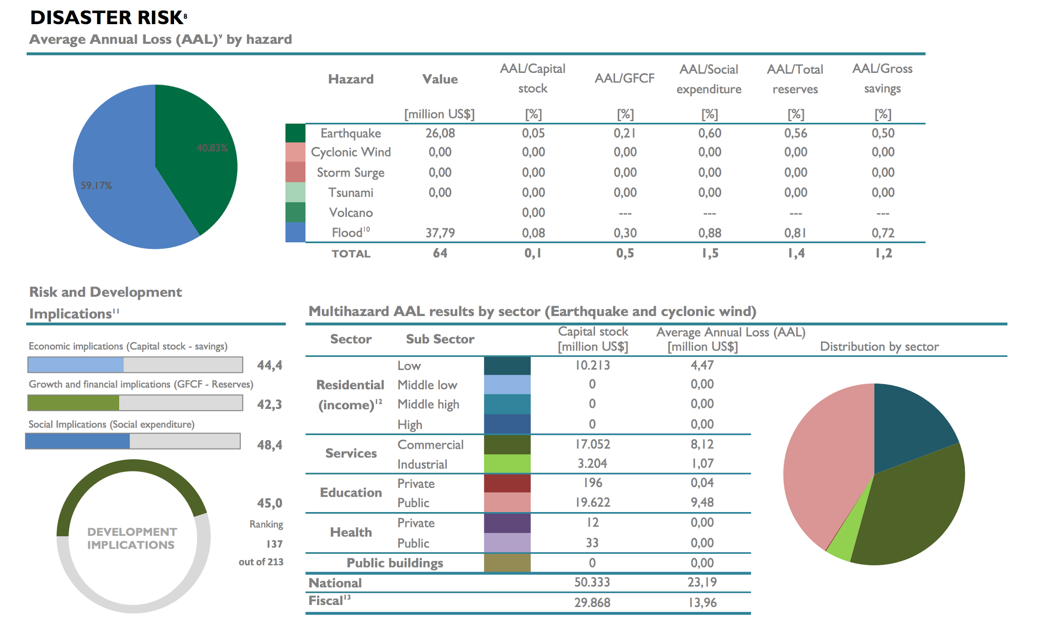

Key disaster risks for Tanzania - image courtesy <http://www.preventionweb.net/english/hyogo/gar/2015/en/profiles/GAR_Profile_TZA.pdf>

Losses resulting from disasters in Tanzania - Image courtesy <http://www.preventionweb.net/english/hyogo/gar/2015/en/profiles/GAR_Profile_TZA.pdf>

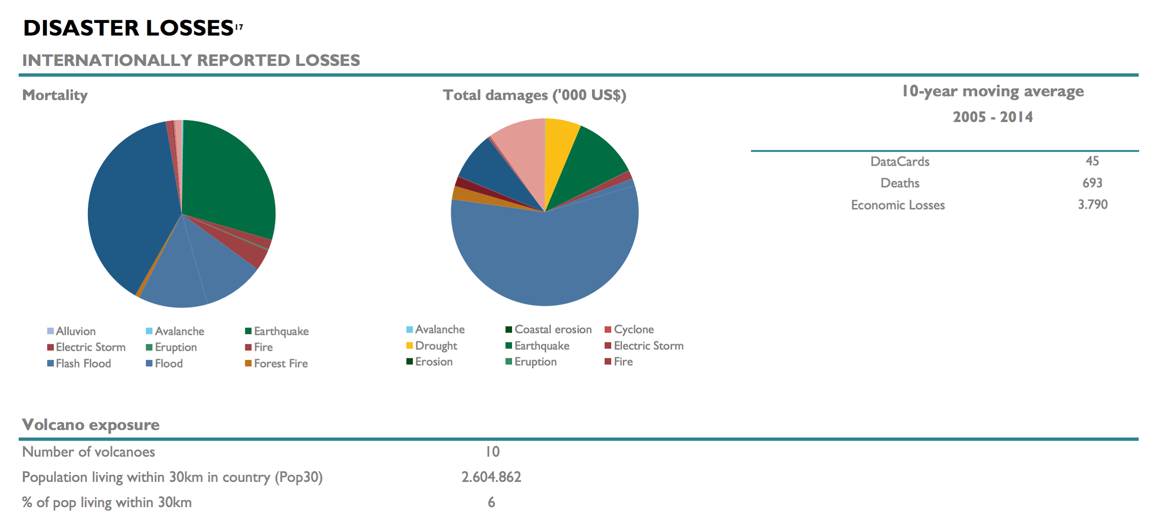

In the InaSAFE project we strive to provide a tool that will enhance the abilities of disaster managers to prepare for disasters and reduce the impact of those disasters on the local population and infrastructure.

## Open Source

From the beginning, InaSAFE has been an Open Source project (GPL license). This means there are no licensing fees, the software can be freely copied and shared with anyone, and the source codes used to create the software are freely available which means that anyone with a little technical knowledge can contribute to the project. Being an Open Source project is important for us because we want as many people as possible to be able to use and improve the software. If “better planning saves lives”, having a tool that can be used by everyone to do better planning makes sense right?

## Open Data

A key driving force in the ability to use tools such as InaSAFE is open access to relevant, up-to-date and well maintained geospatial data. Without roads, buildings, administrative areas, flood and population data etc., a tool like inasafe would be impossible to use.

OpenStreetMap.org, WorldPop and many government and non-government agencies around the world have been leading the effort to make such datasets available. We cannot emphasise enough the importance of government in taking a lead role in making their data freely available so that it can actually be used for the benefit of their citizens.

## InaSAFE promo video

<http://data.inasafe.org/Movies/InaSAFE_Promo_EN.mp4>

YouTube link to WB video

# **Key concepts in disaster contingency planning with InaSAFE**

In this session we explain the basic concepts of InaSAFE and the merits of developing a disaster contingency plan.

## What is a contingency plan?

“A **contingency plan** is a plan devised for an outcome other than in the usual (expected) plan” - <https://en.wikipedia.org/wiki/Contingency_plan>

In the context of disaster management, the expected ‘normal’ situation is that there is no disaster in progress, and people are going about their normal daily lives. Disaster managers need to plan for the occasions when the ‘normal’ situation has been supplanted by a disaster and people can no longer go about their normal daily lives. In order to prepare for such situations, disaster managers need to have a basic understanding of questions like:

* how many people might be in the affected area?
* how might those people be impacted? For example are they likely to be injured, stranded, deceased, unable to continue with their normal economic activities, have they lost access to food and water?
* how will roads in the affected area be impacted?
* how many dwellings in the affected will be affected? And to what degree? For example in a flood are buildings dry, wet (but still possibly habitable) or flooded (with occupants evacuated)?
* if people are affected, how many of them are likely to be women, children, pregnant, elderly etc.?

Knowing the likely answers to these questions can be immensely helpful to disaster managers. For example if you are aware of how many people live in flood prone areas you can estimate how many temporary shelters might be needed in the event of a disaster, how many provisions should be stockpiled in order to provide for the daily needs of affected people and so on. Having demographic breakdowns for the people are likely to be affected, can help disaster managers include things like special dietary requirements for lactating women in their contingency plans.

A contingency plan might also take into account expected impacts on infrastructure - for example by planning to have sufficient rescue boats should all the local roads be flooded.

## What is a hazard?

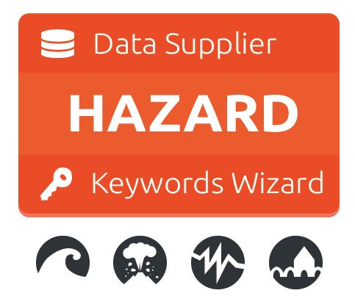

In the context of InaSAFE a hazard is any natural or human caused event or series of events that may negatively impact the population, infrastructure or resources in an area.

Some examples of natural hazards:

* a flood (caused by overflowing rivers, storm surge etc, localised precipitation that cannot drain effectively, or by engineering failure such as a dam or levee breach)
* an earthquake and the resulting ground shaking that is produced by it
* a volcano and the resulting lava flow from a volcano
* ash fall from a volcano
* a tsunami

Some examples of non-natural hazards:

* a chemical spill
* a nuclear plant failure
* an industrial fire / explosion

It is important to note that InaSAFE is **not a hazard modelling tool**. That means that you need to source your hazard data from elsewhere and bring it along ready to use in InaSAFE. In this training course we will be focussed on flood hazards, so we will take a moment here to explain how one goes about creating hazard datasets.

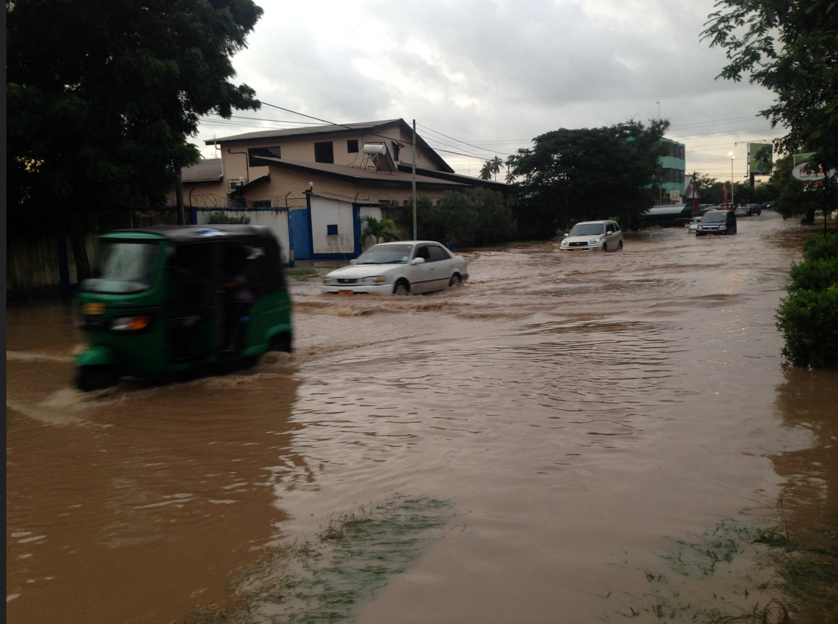

Flooding in Dar es Salaam - Image courtesy [Paul D. Stephens](https://www.flickr.com/photos/53702904@N02/)

There are three primary mechanisms that can be used to generate flood hazard datasets:

1. Remote sensing
2. Local knowledge
3. Modelling

### Remote sensing

This is done using remote sensing equipment (e.g. a drone, airplane or satellite based sensor) that overfly the flooded area taking images. With remote sensing or GIS software these images can be mosaicked (combined) into a single aerial image and the flooded areas captured. The capture process can either be:

* **manual** - by digitising the flooded polygons as a polygon layer by tracing over the image
* **semi-automated** - a remote sensing specialist could use software to classify the image and extract the flooded area.

Typically the process for calculating flooded areas would include taking a pre-flood ‘control’ image and then an in-flood image. The extents of water each stage would be extracted from the imagery and then subtracted from each other. This result will be a flood footprint. In other cases it may be sufficient to simply have the current flood situation mapped during a disaster and perform analysis based on that.

Remote sensing can be extremely fast and effective for capturing large areas, but it also has potential issues. For example during flood events there is often a lot of cloud over the flooded area making the process difficult. It is also possible to use non-visible spectrum (e.g. radar) remote sensing techniques to detect flood waters, but there is an issue with costs associated with this approach - it is often prohibitively expensive. For a nice presentation about using SAR (RADAR) data for flood mapping see:

<http://earth.eo.esa.int/download/eoedu/Earthnet-website-material/to-access-from-Earthnet/2009_ROSA-ESA-DLR-Radar-Remote-Sensing-Course/Flood_detection_principles_TSX.pdf>

|  |  |
| --- | --- |
| **Summary** | |
| Single event usage? | Yes - each dataset is typically for a single event |
| Multi event usage? | Yes, by combining flood areas from two or more events |
| Accuracy | Can be very good |
| Pros | Can cover large areas |
| Cons | May not work due to cloud cover, can be expensive to circumvent this. |

### Local Knowledge

This is probably the most practical way to gather flood data fast, though with lower precision than using remote sensing techniques. One approach that has been effective in Indonesia is to hold mapping workshops where village chiefs / local officials are invited. The officials are asked to indicate which wards / sub-wards within their responsibility area flood regularly.

Instead of simply mapping which wards are flooded, it is also possible to take another approach and map per event, using the same boundaries (wards or subwards). During the event a help desk environment can be used to call out to an official from each ward and query the status of the flood waters in their ward. This approach can also be used via a website (if internet accessibility permits) or by using social media such as twitter. Two examples of this are shown below.

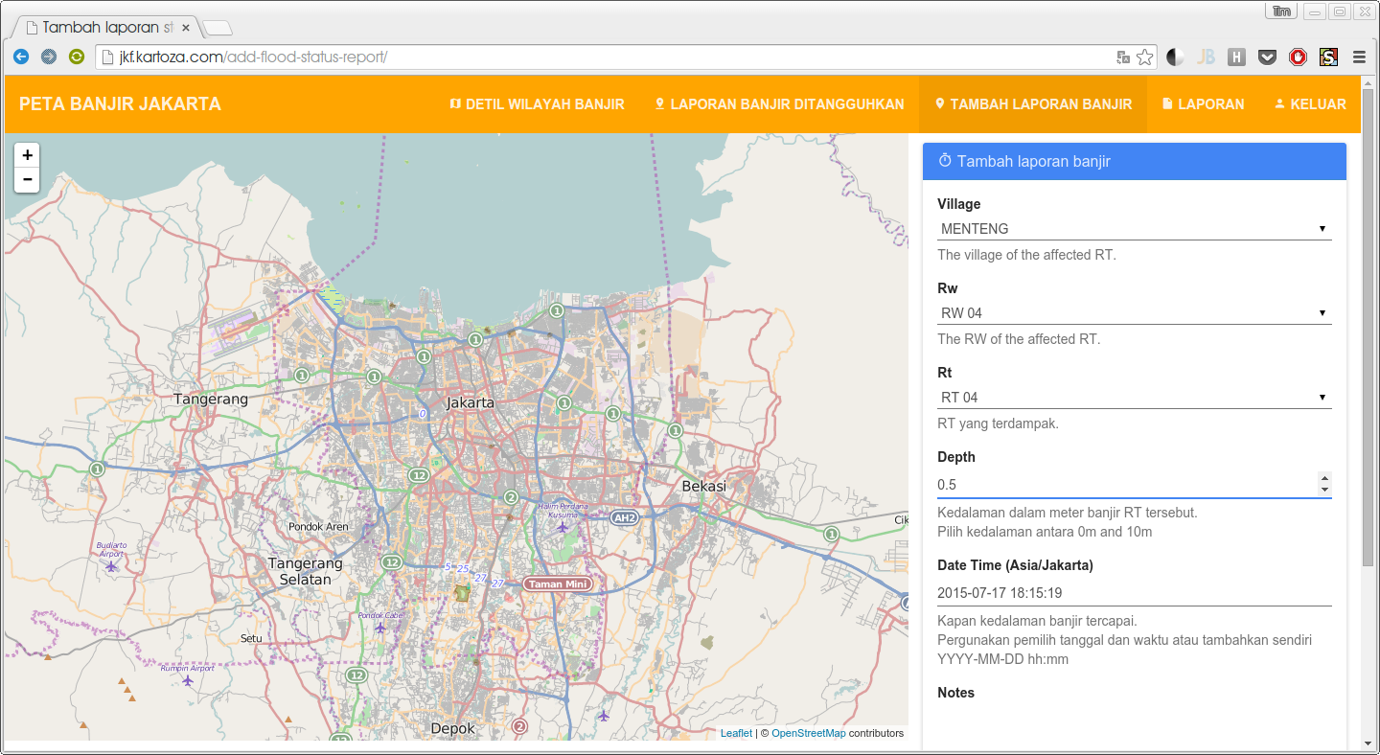

Jakarta Flood Mapper - <http://jkf.kartoza.com>

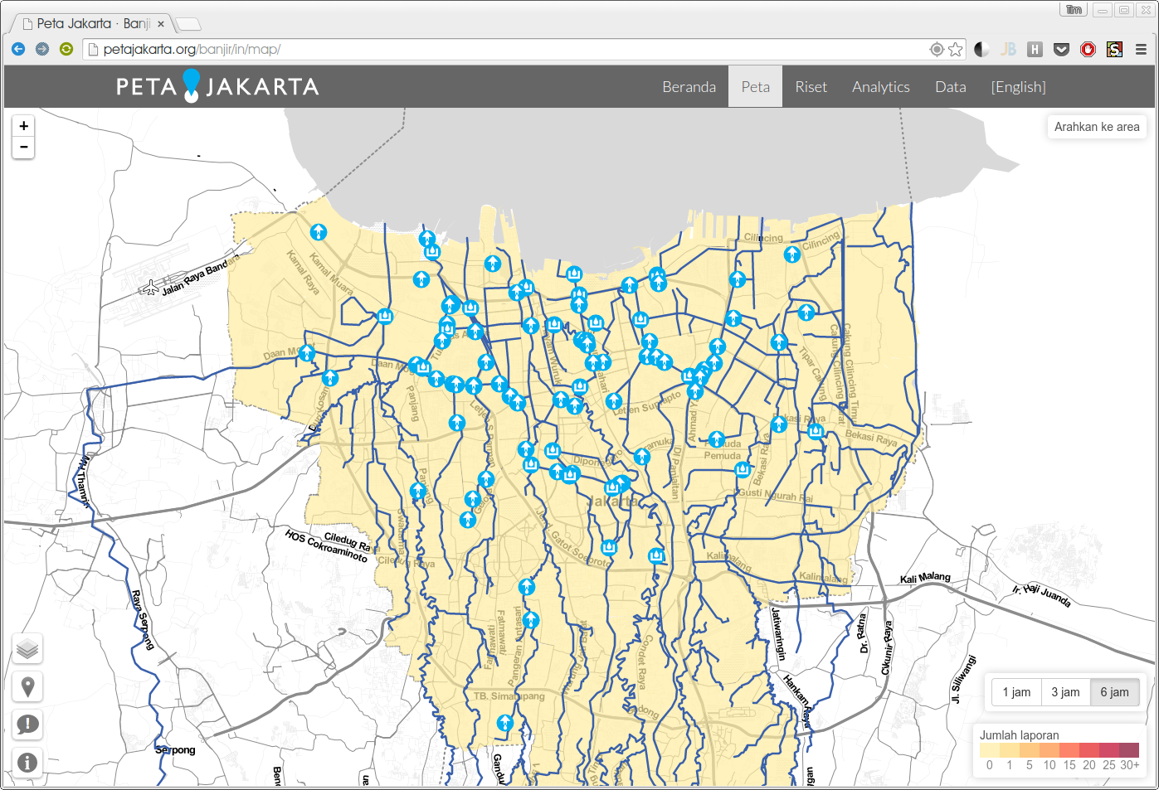

Peta Jakarta - <http://petajakarta.org/>

A key requirement for these local knowledge based processes is that there are suitable mapping units available to use for deciding if an area is flood prone or not. In some cases participants may need to capture these, in other cases ward or sub-ward boundaries can be used. Using sub-ward boundaries may not always be ideal since the flood extents most likely do not align well with the boundaries, but it may be sufficient for broad planning purposes.

|  |  |
| --- | --- |
| **Summary** | |
| Single event usage? | Yes |
| Multi event usage? | Yes, local knowledge typically will span multiple events |
| Accuracy | Typically only accurate to subward level |
| Pros | Fairly quick to create the data, does not require sophisticated technology |
| Cons | Susceptible to human error and coarse accuracy |

### Modelling

Modelling floods is an entire discipline in it’s own right. Flood modelling can be carried out by combining factors such as precipitation, geology and runoff characteristics, terrain etc. to derive a model of impending or current flood. Modelling can use data interpolation techniques - e.g. by taking flood depth readings manually or using telemetry from various sites around the flood prone area, flood depths can be interpolated to estimate the depth at places that were not sampled.

Another modelling approach used by engineers is to install depth sensors upstream of the catchment and then try to model how much water is coming into the catchment area based on depth and flow rates. This has the potential advantage of giving early warning before floods enter the flood prone area, although it also has the disadvantage that localised rainfall may not be accurately considered in the model.

Using a digital elevation model (DEM) and a stream network, it is also possible to generate a simple model of which areas might be inundated by a water rise in the river network of a certain amount. DEM cells adjacent to the stream network which are below the flood-rise threshold will be considered flooded and then those cell neighbours can in turn be considered so as to ensure that only contiguous areas in the DEM are flagged as inundated. There are various other approaches that can be used to model flood potential that involve using a DEM.

One advantage of using a modelling approach is that it allows us to do forecasting for abnormal events. For example, there may not be localised knowledge about 50 or 100 year flood events and their impacts, but these can be estimated using modelling techniques.

|  |  |
| --- | --- |
| **Summary** | |
| Single event usage? | Yes |
| Multi event usage? | Yes |
| Accuracy | Accuracy may be very variable depending on the datasets used the the algorithms employed. |
| Pros | Does not require large amounts of human input, may provide insight into the impact of extraordinary events such as 100 year floods. |
| Cons | A large number of techniques available make it difficult to choose an appropriate one. Algorithm parameters need to be carefully tuned and a high confidence in the input data used for modelling is needed. |

### Single versus multi-event hazards

Hazard data used in InaSAFE can be either single event or multi-event. Single event hazards are useful when you want to estimate scenarios like ‘how many people would be affected if we had another flood like in 2007’. A single event hazard covers a short span of time - like a single flood or earthquake event. Single event data is also the most suitable to use for events which are stochastic e.g. earthquakes which seldom occur at the same place and with the same intensity more than once.

Multi-event data are useful when you would like to plan for disasters that repeatedly affect the same area. For example over the course of 10 years, the same wards or sub-wards may get flooded, though not on every event. Flood and volcano eruptions may be good candidates for using multi-event data in your contingency planning.

### Some tools that can be used for flood modelling

The techniques that are available in GRASS for modelling floods are:

* r.hazard.flood which is an extension in grass and the instructions on how to do that are accessed on the grass wiki. <http://grass.osgeo.org/grass70/manuals/addons/r.hazard.flood.html>
* r.lake and r.rake.series. r.lake is available in grass and can also be accessed via the processing interface in qgis and run for each simulation. r.lake.series is a grass extension only available in grass 7 which also supports simulation through the nviz module in grass.

<http://grass.osgeo.org/grass64/manuals/r.lake.html>

* r.terraflow. Mainly used for flood modelling for rasters that are big. There are two variations of r.terraflow which stem from the type of data the dem has. For cell type data there is r.terraflow.short which is used for this and is available in grass 6. <http://grass.osgeo.org/grass64/manuals/r.terraflow.html>

Techniques available in QGIS:

Using the processing module in QGIS one can access the modules in SAGA,OTB and GRASS. Installing a plugin named Geospatial Simulation also enables different flood modelling techniques to be visible in the processing toolbox. The instructions on how to undertake these processes can be accessed at their respective website/wiki or any other blog articles that describe the processed carried out.

Requirements for using flood data in InaSAFE

|  |  |
| --- | --- |
| **Key notes for floods** | |
| Format | Vector polygon data or raster data |
| Required fields | Applies to vector flood data only: A field representing whether the polygon is flood prone or not. We recommend calling this field **‘FLOODPRONE’** and using a value of ‘**YES**’ to indicate that it is flood prone. |
| Notes | InaSAFE does not need ‘engineering quality’ data.  When provided in raster format, each cell value will typically represent a flood depth in meters. |
| Sourcing | Can be sourced from community mapping efforts, from your national mapping agency. |

### What is exposure?



In the context of InaSAFE, exposure refers to people, infrastructure or land areas that may be affected by a disaster. Currently InaSAFE supports three kinds of exposure data:

* population / people
* roads
* buildings

### Population data



Population data can often be obtained by your census bureau or through various online data sources. One problem with population data is that it is often quite coarse (represented using a raster with a large pixel size) and so analysis at large scales (e.g. a small neighbourhood) using population data may not always be the best idea. Currently InaSAFE only supports raster based census data, but in the near future we will be releasing a version that supports assigning population estimates to buildings using census data. One of the nicest online resources for population data is [‘WorldPop’](http://www.worldpop.org.uk/data/files/index.php?dataset=TZA-POP&action=group) - a project that aims to provide population data for anywhere in the globe produced in a standardised and rigorous way.

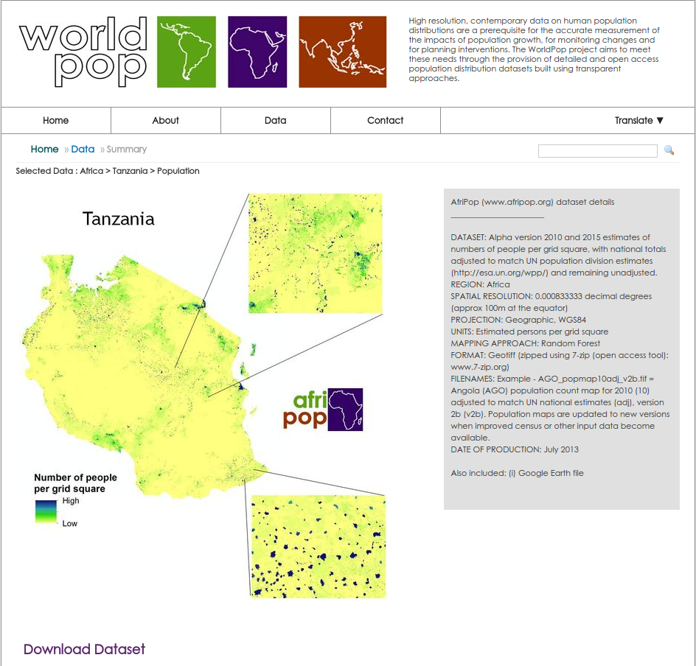

There are two common representations for raster population data:

1. **Density**: In this representation each cell in the population dataset contains the number of people per measurement unit - for example people per m2.
2. **Counts**: In this representation each cell contains the actual number of people thought to be resident in that cell.

Understanding if your population data is density or counts is important as the processing of density data needs to be done differently if the cells contain density compared to if they contain counts. For example If you are resampling the dataset (reducing or enlarging the pixel sizes), count data would first need to be converted to a density (e.g. 50 people / m2), the resampling carried out, and then converted back to a count.

**Note:** The data provided by WorldPop contains **counts** of people per cell and the cell size is approximately 100m.

|  |  |
| --- | --- |
| **Key notes for population data** | |
| Format | Raster ‘cell’ data |
| Requirements | Currently the data should be in EPSG:4326 CRS |
| Notes | Be sure you know whether you are dealing with density or count data. |
| Sourcing | WorldPop or from national government datasets. |

### Roads data



Roads / streetline datasets are a useful datasource when you want to understand the impact of a flood on roads infrastructure. With the InaSAFE flood on roads impact functions, you can calculate which roads of which type might be impacted by a flood.

Very often there will be national datasets available for roads. In this case you should contact your national mapping agency for up-to-date datasets.

The OpenStreetMap project is an excellent source of exposure data.The data is freely available, generally well maintained and a vital resource for contingency planners. There are numerous ways to download OpenStreetMap roads data, but our recommended way is to download the data using the baked-in tool provided with InaSAFE.

|  |  |
| --- | --- |
| **Key notes for roads** | |
| Format | Vector line data |
| Required fields | A field representing road type |
| Notes | Topologically correct data is ideal - that is road intersections should converge properly |
| Sourcing | Can be sourced from community mapping efforts in OSM (using the built in tool in InaSAFE makes this easy) or from national government datasets. |

### Buildings (structure) data



Like roads, buildings footprints can be a useful dataset to have for understanding the impacts of a flood. For example you may wish to know ‘how many buildings might be flooded, and what types of buildings are they?’.

In InaSAFE you **do not need** to use engineering quality data. We are more concerned with the numbers and types of structures affected by a disaster and do not work at engineering tolerances needed when, for example, planning a new water mains system.

|  |  |
| --- | --- |
| **Key notes for buildings** | |
| Format | Vector polygon data |
| Required fields | A field representing building type |
| Notes | InaSAFE does not need ‘engineering quality’ data. |
| Sourcing | Can be sourced from community mapping efforts in OSM (using the built in tool in InaSAFE makes this easy) or from national / local government datasets. |

### What is aggregation?

Aggregation is the process whereby we group the results of the analysis by district so that you can see how many people, roads or buildings were affected in each area. This will help you to understand where the most critical needs are, and to generate reports as shown in the image below.

Aggregation is optional in InaSAFE - if you do not use aggregation, the entire analysis area will be used for the data summaries. Typically aggregation layers in InaSAFE have as attributes the name of the ward or reporting area. It is also possible to use extended attributes to indicate the ratio of men and women, children, adults and elderly living in each area. Where these are provided and the exposure layer is population, InaSAFE will provide a demographic breakdown per aggregation area indicating how many men, women etc were probably affected in that area.

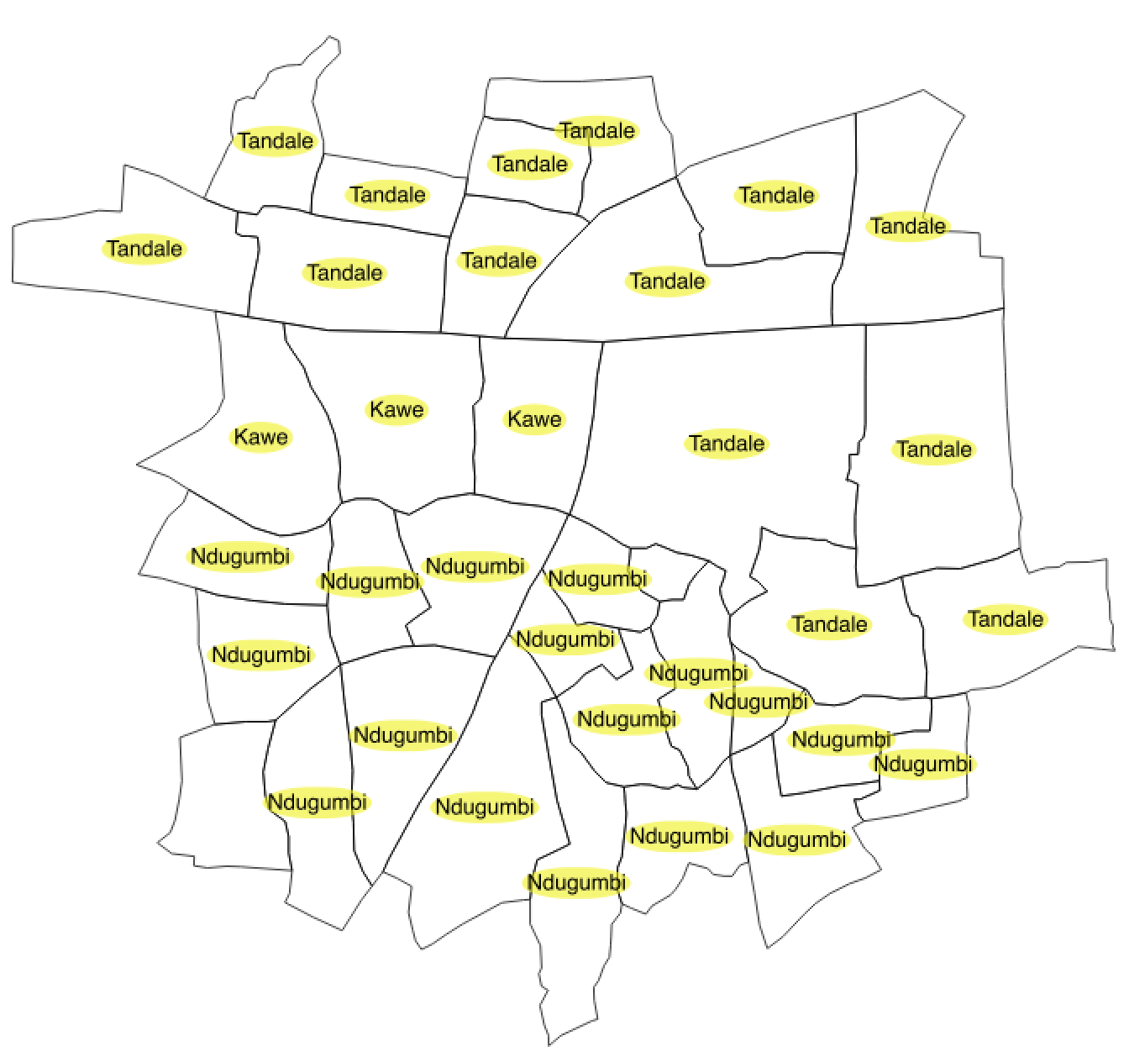

Wards can be used to aggregate results.

Below we can see an example where InaSAFE has been used to generate aggregated results and the exported data was used to make a visually informative report.

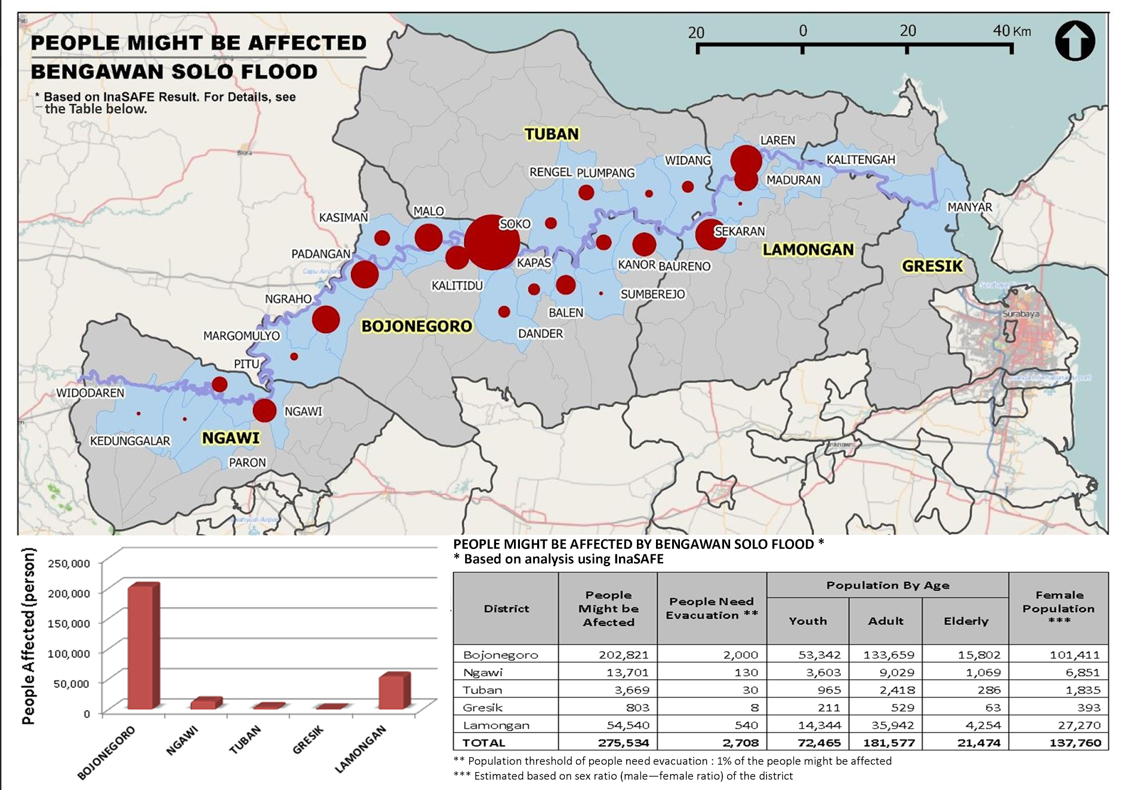

Image courtesy HOTOSM, Indonesia and DFAT

### What is contextual data?

Contextual data are data that provide a sense of place and scale when preparing or viewing the results of analysis, while not actually being used for the analysis. For example you may include a hillshaded image to show the underlying relief of the study area, or an aerial image to show what buildings and infrastructure exist in the area.

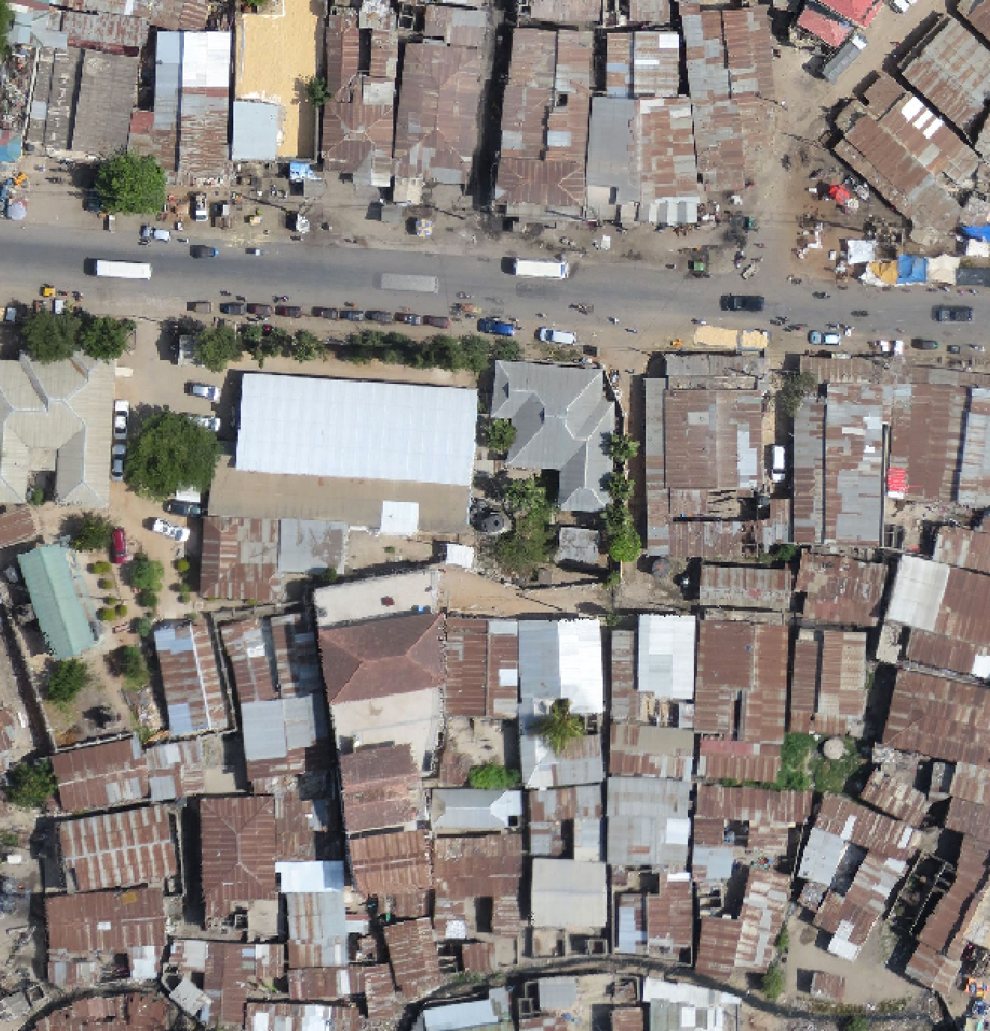

Sensefly aerial imagery for Tandale, courtesy Tanzania Open Data Initiative

### What is continuous vs. classified data?

In InaSAFE we differentiate between data which is continuous and data which is classified. The terms can be applied equally to both hazard and exposure data.

**Continuous** data represent a **continuously varying phenomenon** such as depth in meters, population counts and so on.

Continuous population data - courtesy WorldPop

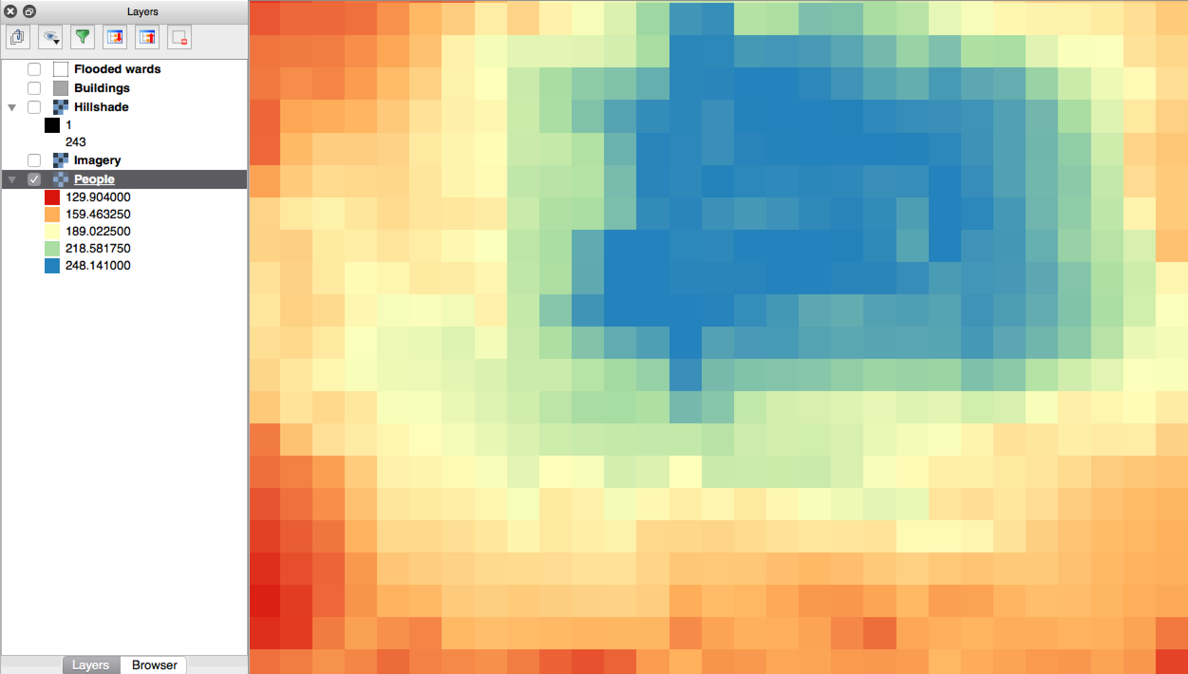

**Classified** data represent **named groups of values**, for example, high, medium and low danger. Grouping values works well when you wish to reduce data preparation complexity or deal with local variances in the interpretation of data. For example, a flood depth of 50cm may represent a high hazard zone in an area where people commonly have basements in their houses, and a low hazard zone in areas where people commonly build their houses on raised platforms.

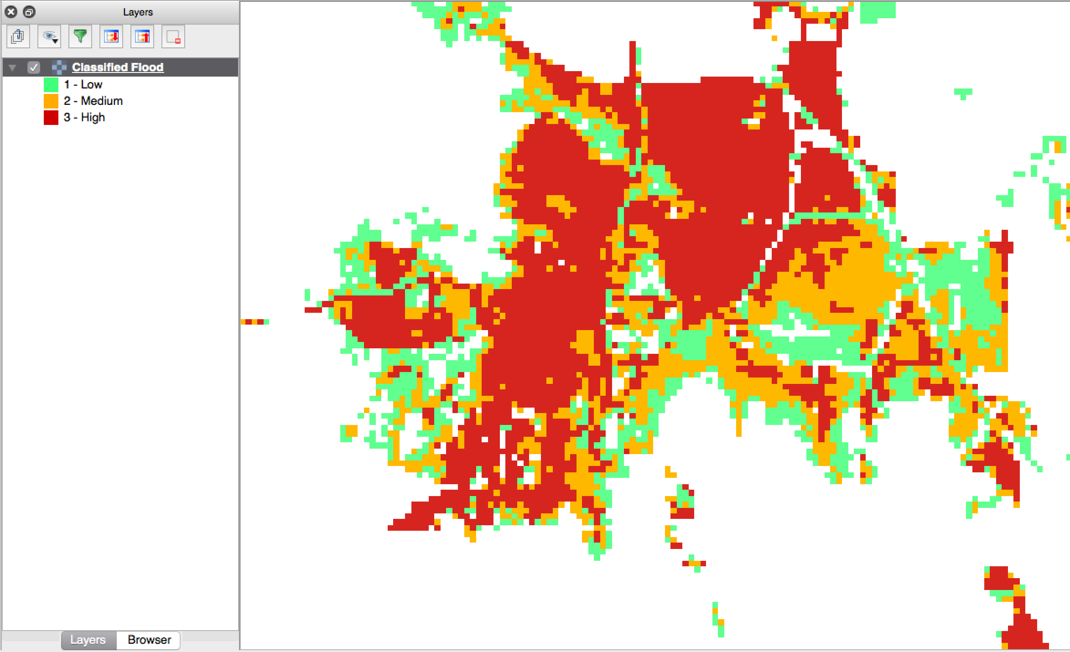

Classified raster flood data - courtesy BNDP/AIFDR

### What is the analysis extent?

In InaSAFE you need to explicitly state what the intended analysis extent should be. In other words, you need to tell InaSAFE **where** the analysis should be carried out. There is a tool in InaSAFE that will allow you to drag a box around the intended analysis area - you should always check that you have done this before starting your analysis.

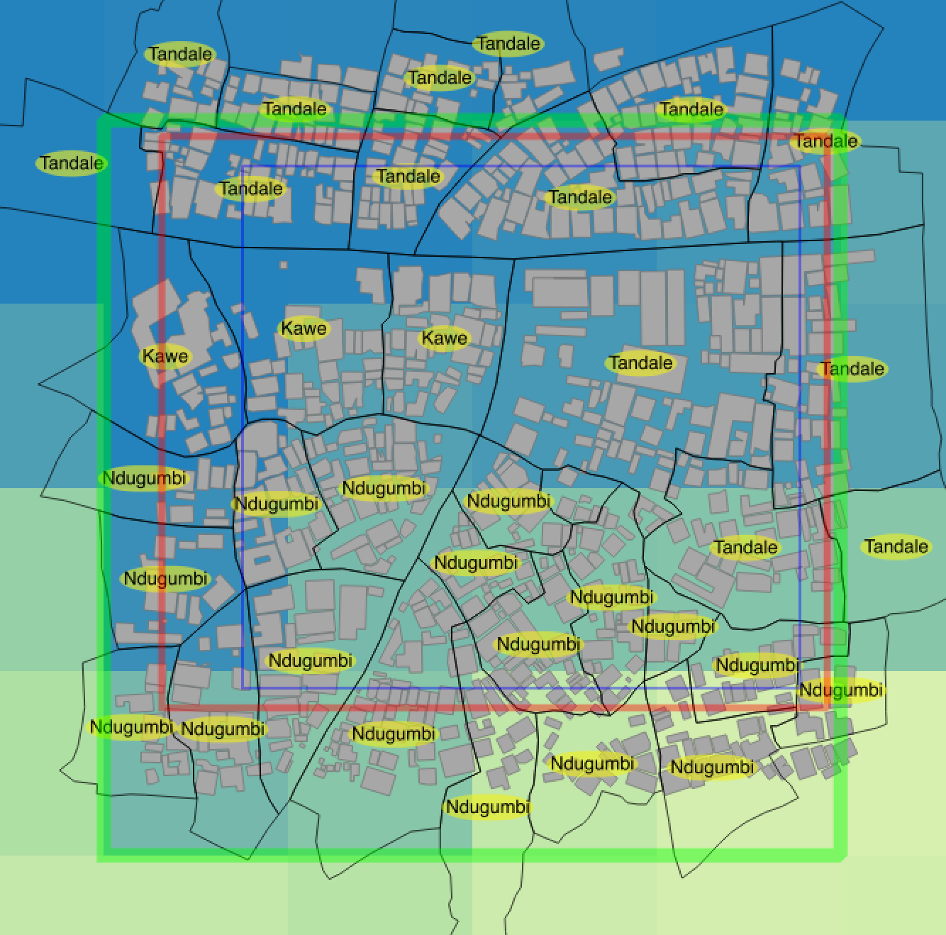

Analysis extent in InaSAFE

InaSAFE will show you what your current desired analysis extent is (blue box in the image above), what the extent of your last analysis was (red box in the image above) and what your effective extent is (green box in the image above). The effective extent may not correspond exactly to your desired analysis extent because InaSAFE always aligns the extent to the edge of raster pixels.

### What is an Impact Function?

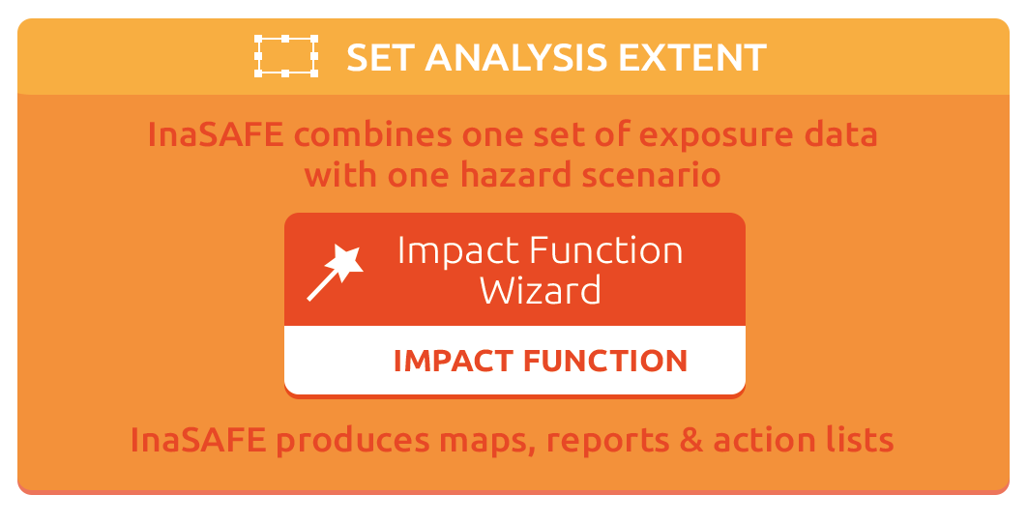

An Impact Function (often abbreviated to IF) is software code in InaSAFE that implements a particular algorithm to determine the impact of a hazard on the selected exposure. Running an impact function is done when you have prepared all your input data, defined your analysis extent and wish to now see the impact outputs.

Again, we should emphasise here that Impact Functions do **not model hazards** - they **model the effects** of one or more hazard events on an exposure layer. InaSAFE groups it’s impact functions according to the kind of hazard they work on:

| Supported data types for each hazard type in InaSAFE | | |
| --- | --- | --- |
| **Hazard Type** | **Supported Hazard Layers** | **Supported Exposure Layers** |
| **Earthquake** | Raster | Continuous raster **population** count  Classified polygon vector **buildings**  Classified point vector **building centroids** |
| **Generic  ?** | Classified polygon | Continuous raster **population** count  Classified polygon vector **buildings** |
| Classified raster | Continuous raster **population** count  Classified polygon vector **buildings** |
| Continuous raster | Continuous raster **population** count |
| **Inundation** | Continuous raster | Continuous raster **population** count Classified polygon vector **buildings** Classified point vector **building centroids** |
| Classified polygon | Continuous raster **population** count Classified polygon vector **buildings** Classified point vector **building centroids** |
| **Volcano** | Classified point | Continuous raster **population** count Classified polygon vector **buildings** |
| Classified polygon | Continuous raster **population** count  Classified polygon vector **buildings** |

A note about generic impact functions: Generic IF’s are useful when your data does not conform to the *a priori* expectations of InaSAFE. For example, you may wish to produce a report on buildings that might be affected by a chemical spill.

Each Impact Function will generate outputs that may include:

* an impact map layer
* an impact summary
* minimum needs
* action checklists



### What is an impact layer?

An impact layer is a new GIS dataset that is produced as the result of carrying running an impact function. It will usually represent the **exposure layer**. For example, if you do your analysis on buildings, the output impact layer will be a buildings layer but each building will be classified according to whether it is dry, wet or flooded. InaSAFE will typically apply its own symbology to the output impact layer to make it clear which are the impacted buildings. This is illustrated in the image below.

It should also be noted that the **impact layer will only include features / cells that occur within the analysis extent**. All others will be ‘clipped away’. It is very important to remember this when interpreting the impact summary (see section below) because the summary is only relevant to the analysis area.

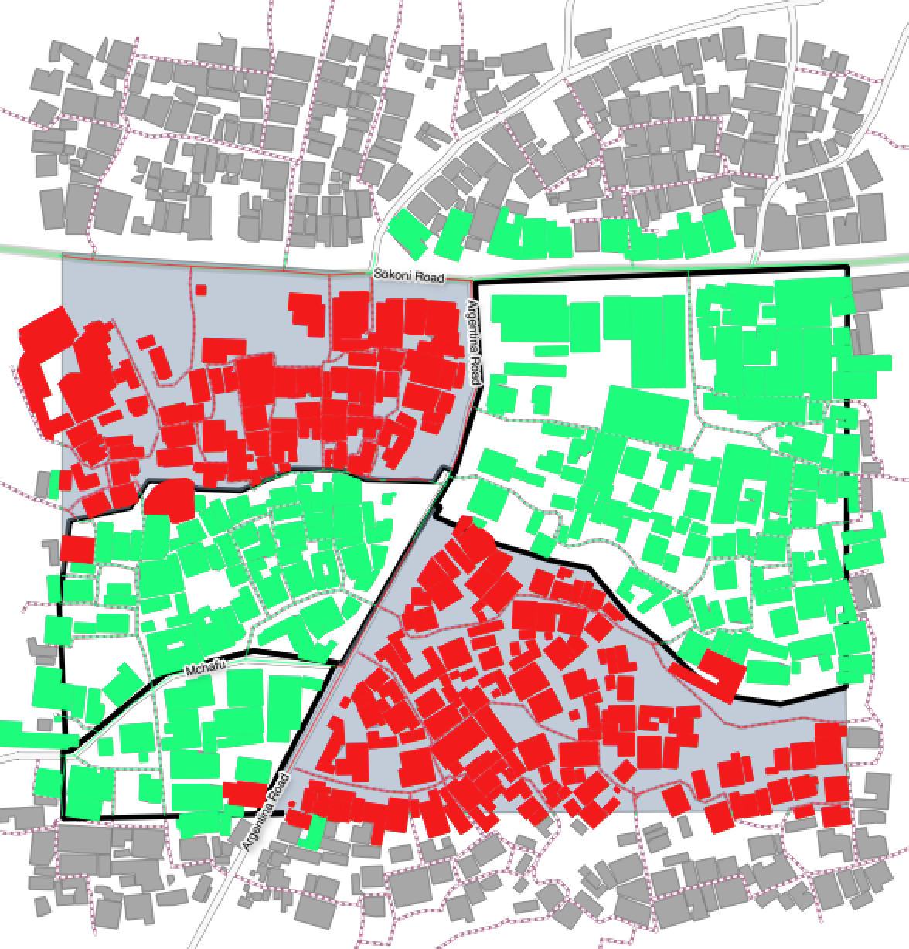

Impacted buildings (red) versus non-impacted (green) versus excluded (gray)

### What is the impact summary?

Whereas the impact layer represents spatial data, the impact summary is **tabular and textual data**. The impact summary details by means of a table (or series of tables) and other textual information the numbers of buildings, roads or people affected, and includes other useful information such as minimum needs breakdowns, action checklists, summaries and so on. The impact summary presents the results of the impact function in an easy to digest form. Our expectation that the numbers show here would form part of your contingency planning process - typically as a launch point for discussion and planning on how to have sufficient resources in order to cater for the impacted people, buildings or roads should a similar event to the one on which the scenario is based occur. An example impact summary is shown below.

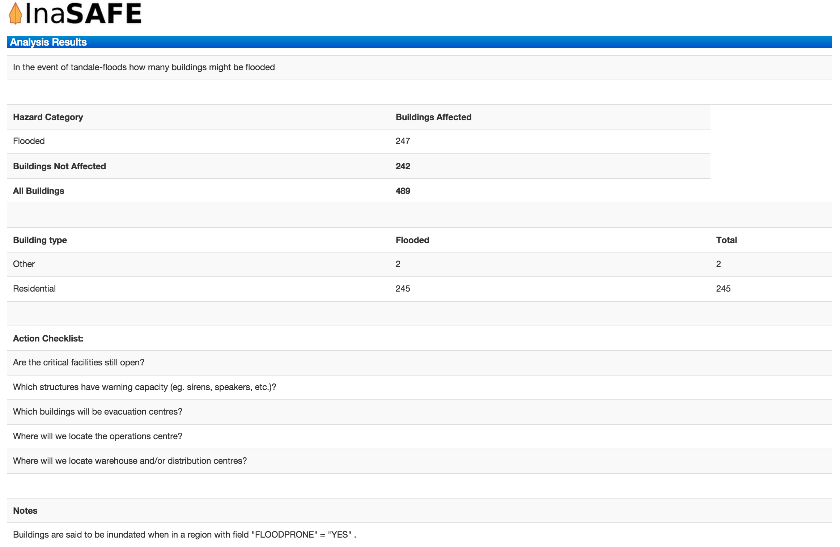

Example impact summary table showing breakdown of buildings flooded.

### What are minimum needs?

Minimum needs are a population specific reporting component for the impact summary. They are based on generic or regional preferences (we will show you how to configure these in the advanced workshop) and define the the daily dietary and well-being requirements for each individual who may be displaced during a disaster. For example you could specify that each person should receive 20l of fresh drinking water per day, 50l of bathing water and so on. InaSAFE will extrapolate these numbers to provide a total needs for the displaced population.

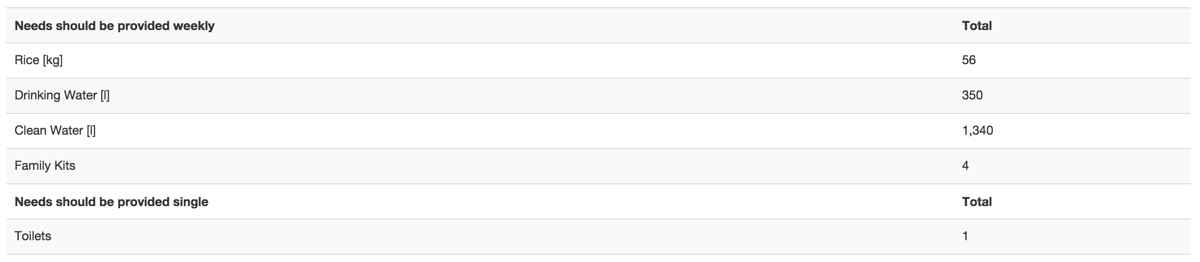

### What are action checklists?

Action checklists are generated lists of things disaster managers should consider when implementing their contingency plan. Currently the action checklists are fairly simplistic - they are intended to prompt discussion and stimulate disaster managers to think about the important contingencies they should have in place.

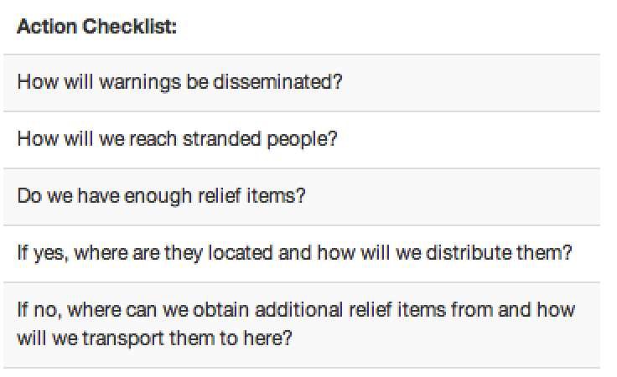

# Setup and Installation of InaSAFE

In order to use InaSAFE, we first need to install it. InaSAFE is provided as a plugin for QGIS (<http://qgis.org>), so you need to have that installed first. We encourage you to use the ‘LTR’ version of QGIS (at time of writing 2.8.2) since this will be the most stable version and we will always ensure that InaSAFE works with the LTR version of QGIS.

Once QGIS is installed (download it from <http://download.qgis.org>), open the plugin manager and search for ‘InaSAFE’ in the plugin search dialog. Then select it from the list of matched plugins and click the ‘Install plugin’ button.

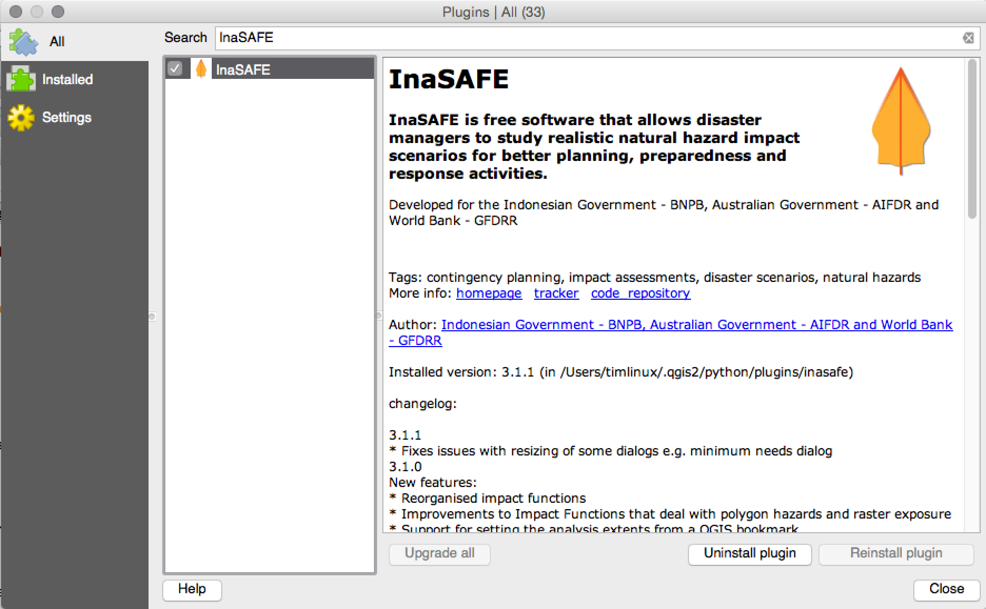

After installation, the InaSAFE dock should appear in QGIS.

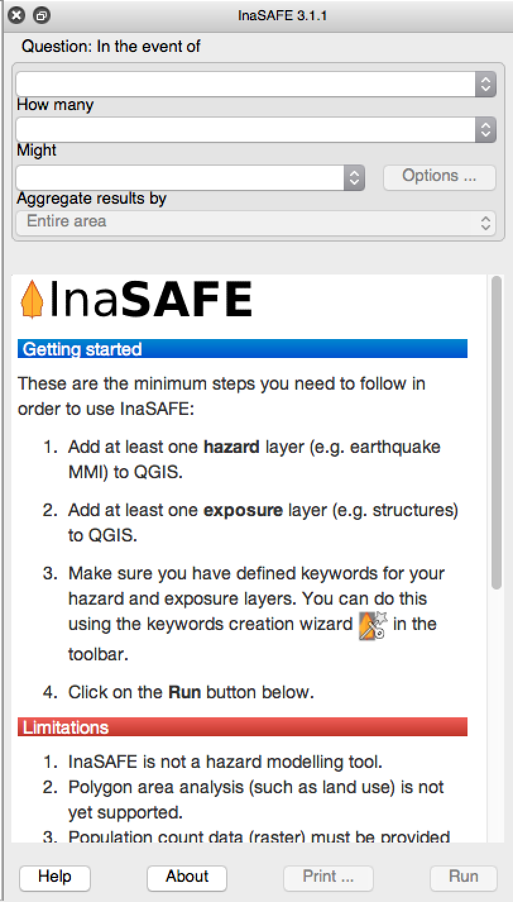

# 

# The InaSAFE workflow

Now that you understand the basic concepts of hazard, exposure, aggregation and analysis extent, let us show you the generalised workflow in InaSAFE.

## Exercise 1 : A flood on population in Dar es Salaam

In this session we will do a walk through of an example scenario where we show how the different data elements are combined in order to analyse the potential impact of a flood in a suburb of Dar es Salaam on the population living in that area.

To start with you should open the project in the folder ‘exercise1/exercise1.qgs’.

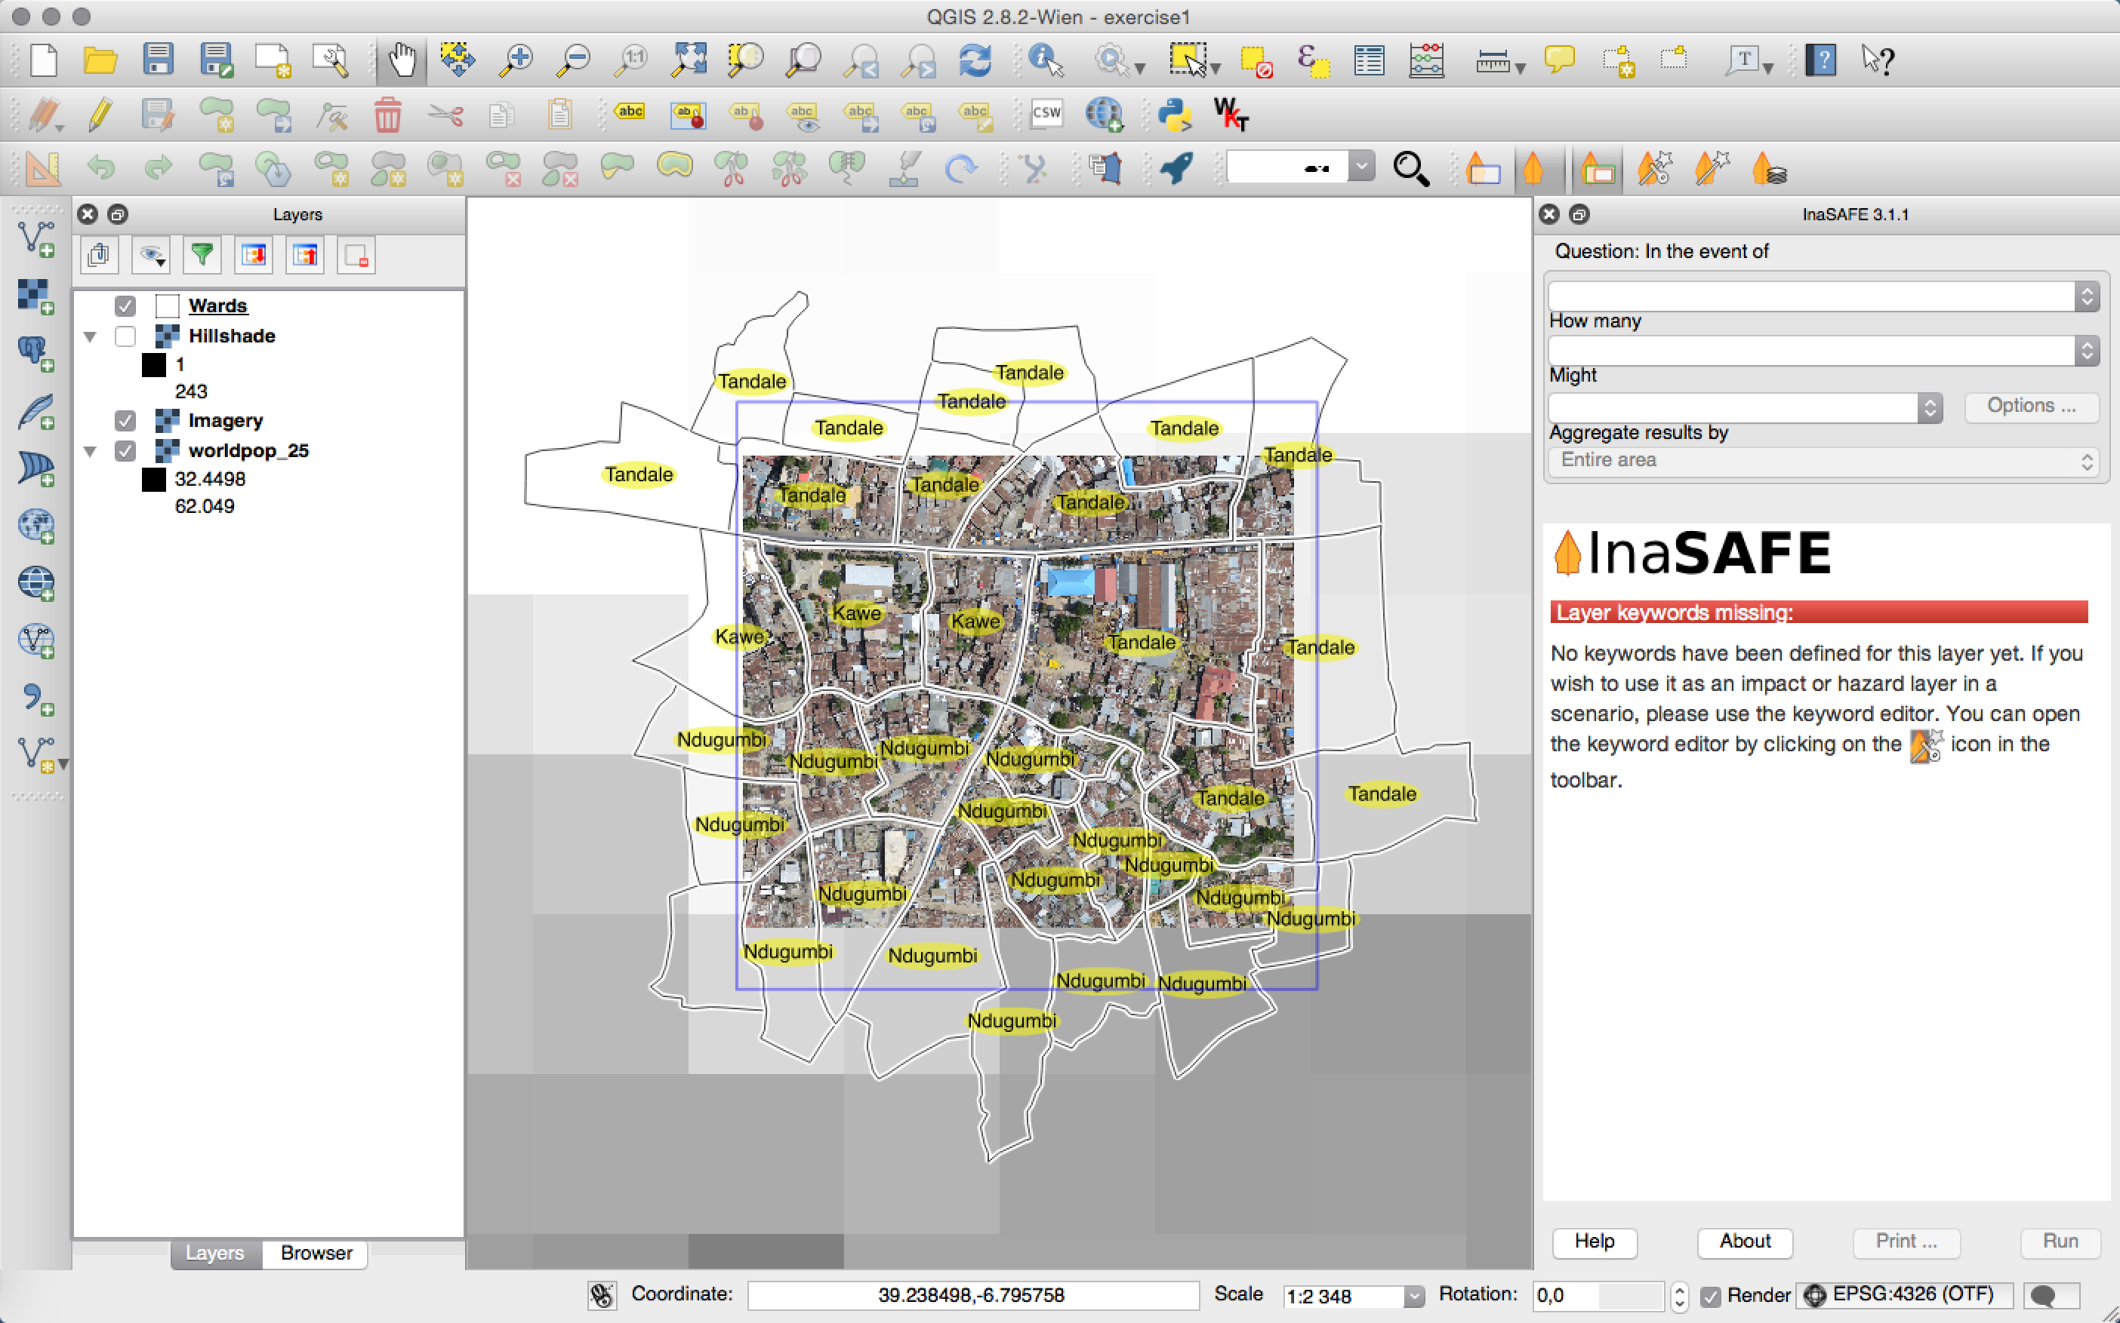

You will see the project has four layers loaded:

* **Wards** - we will use these to indicate which areas are flood prone
* **Hillshade** - this is a rendering from the Digital Elevation Model to show shaded relief
* **Imagery** - this is an image taken by the Sensefly drone over the study area. On this image we can see buildings and roads and other local features of interest.
* **Worldpop 25** - this is a population raster taken from WorldPop and resampled to 25 meters. We also scaled the pixel values appropriately.

### Adding the FLOODPRONE attribute

The first thing we will do is add a column to the wards layer to indicate which are flood prone. To do this we need to use the ‘field calculator’ functionality in QGIS. Follow these steps:

1. Select the Wards layer in the Layers panel and make sure it is highlighted

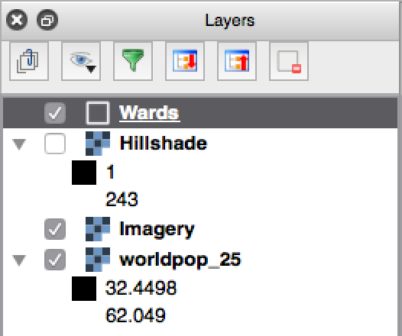

1. Click on the table icon on the toolbar, or do Layer -> Open Attribute Table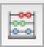
2. Click on the ‘Editing’ icon in the table toolbar
3. Click on the ‘field calculator’ icon in the table toolbar and use the following options as shown in the image below:
   1. Tick ‘**Create a new field**’
   2. Set ‘**Output field name**’ to ‘FLOODPRONE’ (make sure you spell this in capital letters and exactly as shown).
   3. Set the ‘Output field type’ to ‘Text (string)’
   4. In the expression box, enter ‘YES’ (for this exercise we will be marking all wards as flood prone to start with.

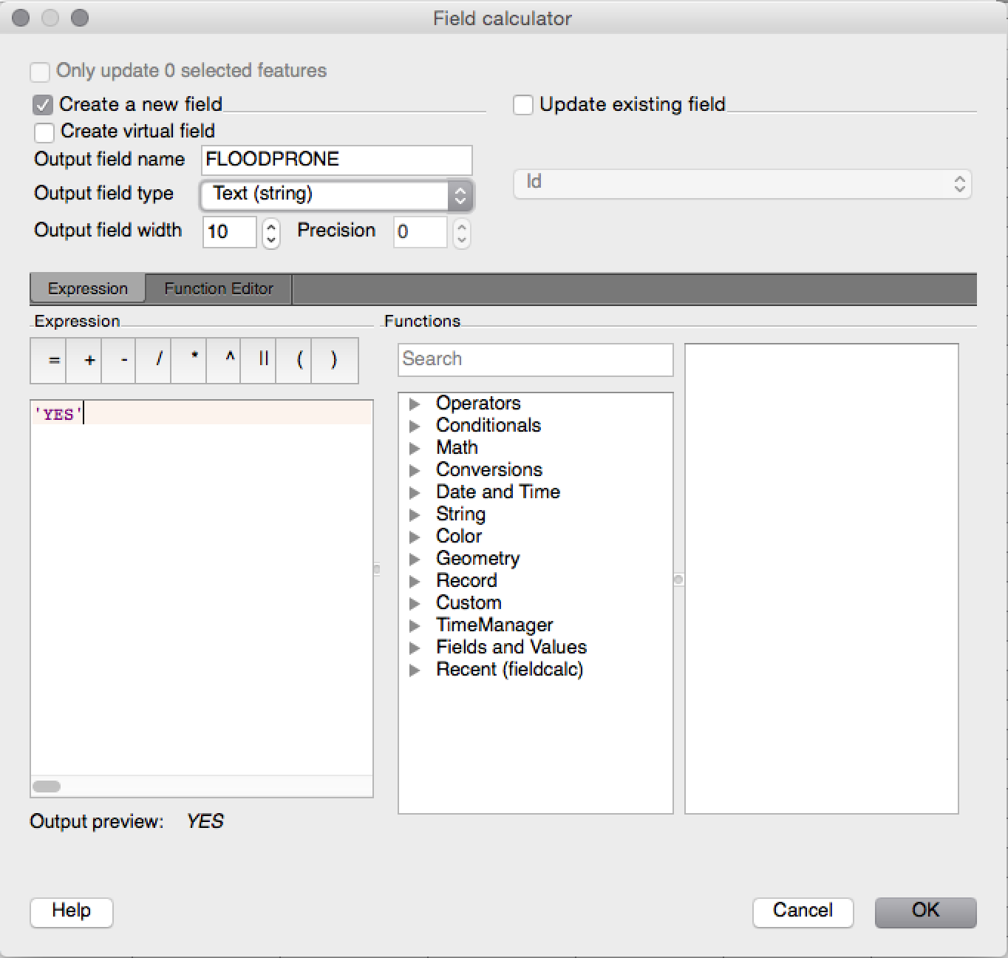

1. Click ‘OK’ in the field calculator to apply your changes
2. Click on the ‘**editing**’ icon in the table toolbar
3. Press the ‘**Save**’ button to save your changes

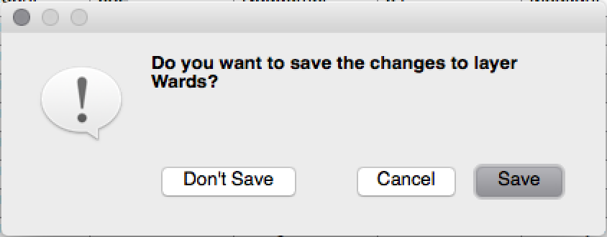

Our wards layer now has an extra column indicating if the ward is flood prone. We will try changing particular wards to ‘NO’ for their flood prone status just now to see how that impacts the analysis outcome.

Now we are going to ‘register’ the layer with InaSAFE by defining keywords for it. To do this we will use the Keywords Wizard. Follow the steps as shown in the series of screenshots below to register the layer as a flood hazard layer.

Select the Wards layer in the Layers panel and make sure it is highlighted (it may already be, which is fine).



Click on the InaSAFE Keywords Wizard in the InaSAFE toolbar   
  
  
In the steps that follow, indicate that the layer is a **hazard, flood, wet / dry** with attribute **FLOODPRONE** being the attribute that indicates whether an area is prone to floods.  
  
  
  
  
On the next page of the wizard, we will indicate that the FLOOPRONE areas are those where the attribute value is ‘YES’. This is already done for you by default, there is no need to do anything so you can just press ‘next’.  
Now we enter some information about the source of the data. Our wards data come from the National Bureau of Statistics enumeration areas dataset, so we will set the source to ‘NBS’ and the url to ‘<http://nbs.go.tz'>. All the entries on this page are optional, put in the best information you have available. Press ‘**next**’ when you are done.

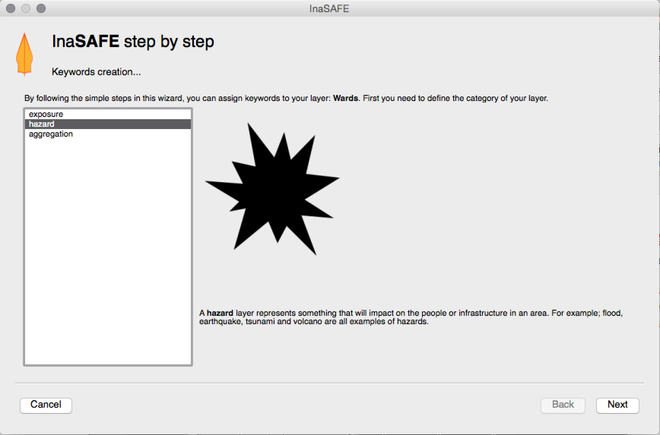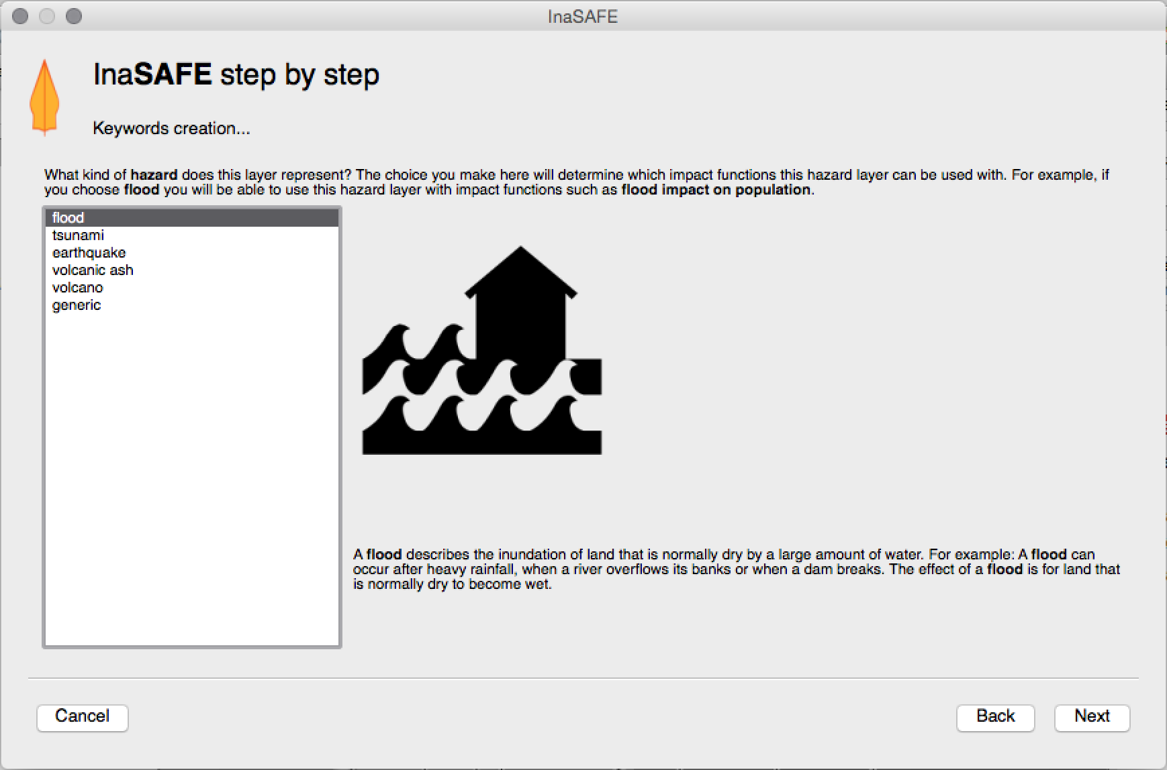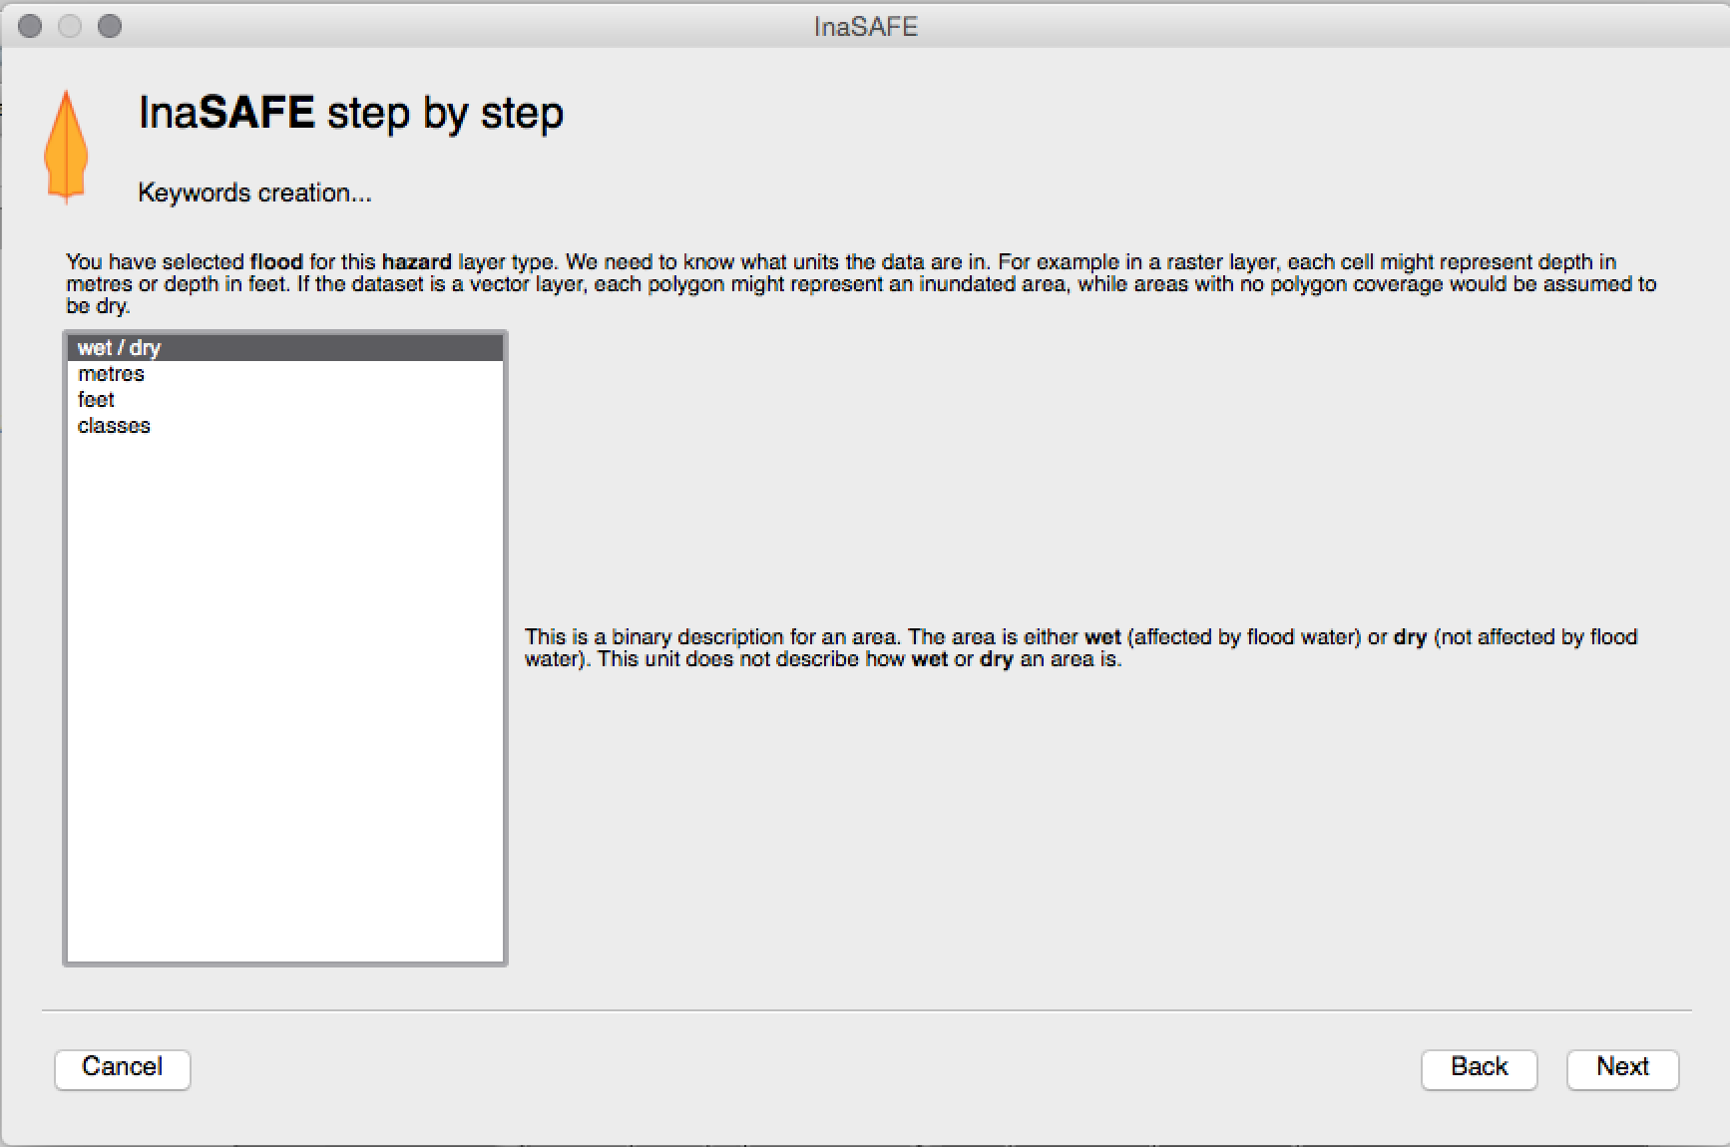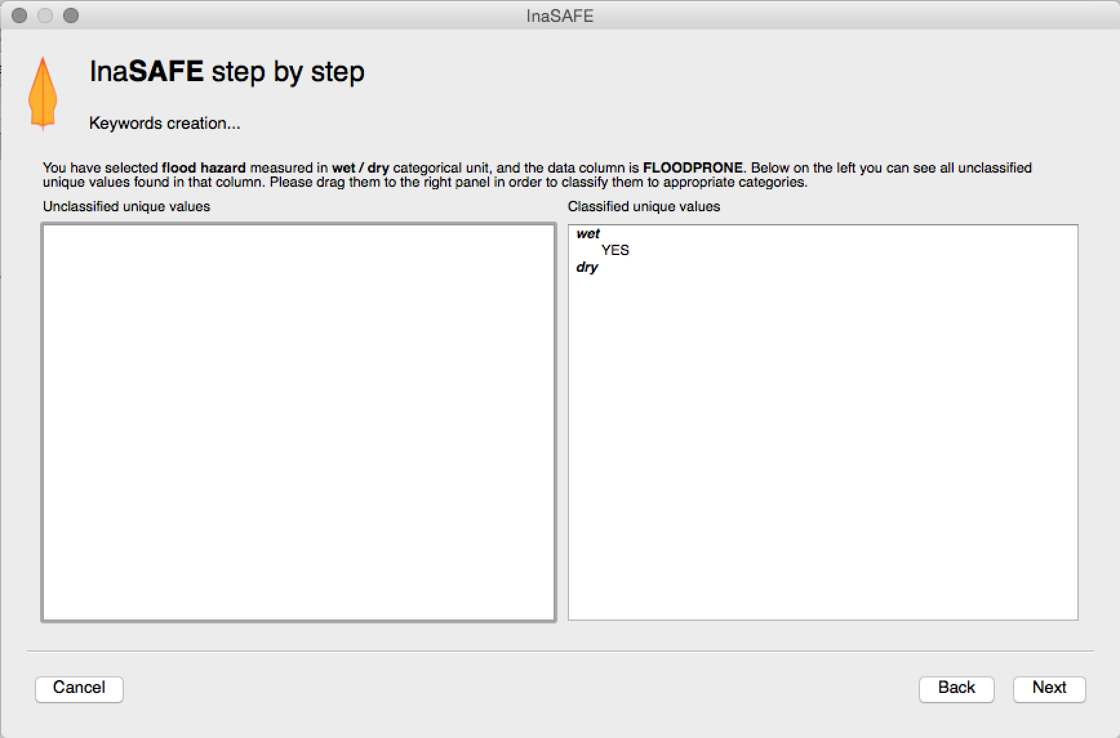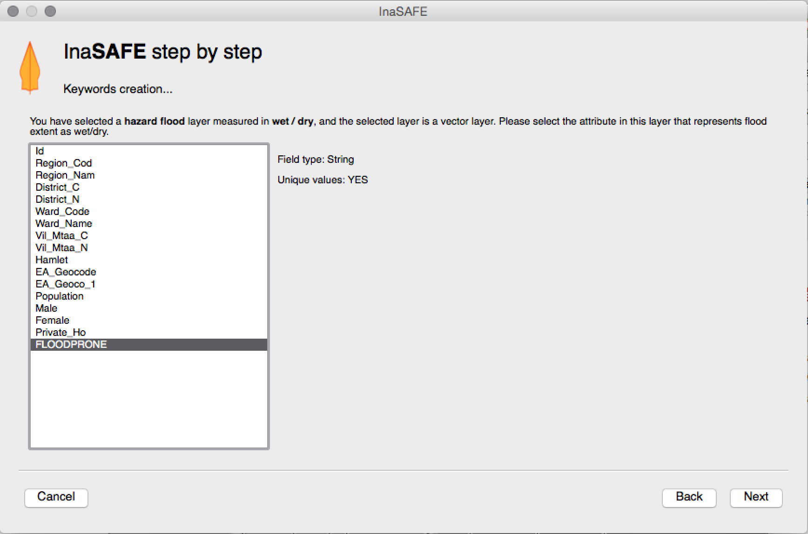

## On the last page of the keywords wizard, you can enter a nice title for the layer. This will be used in the legend and in reports. For now let’s call it ‘Flood prone areas’.

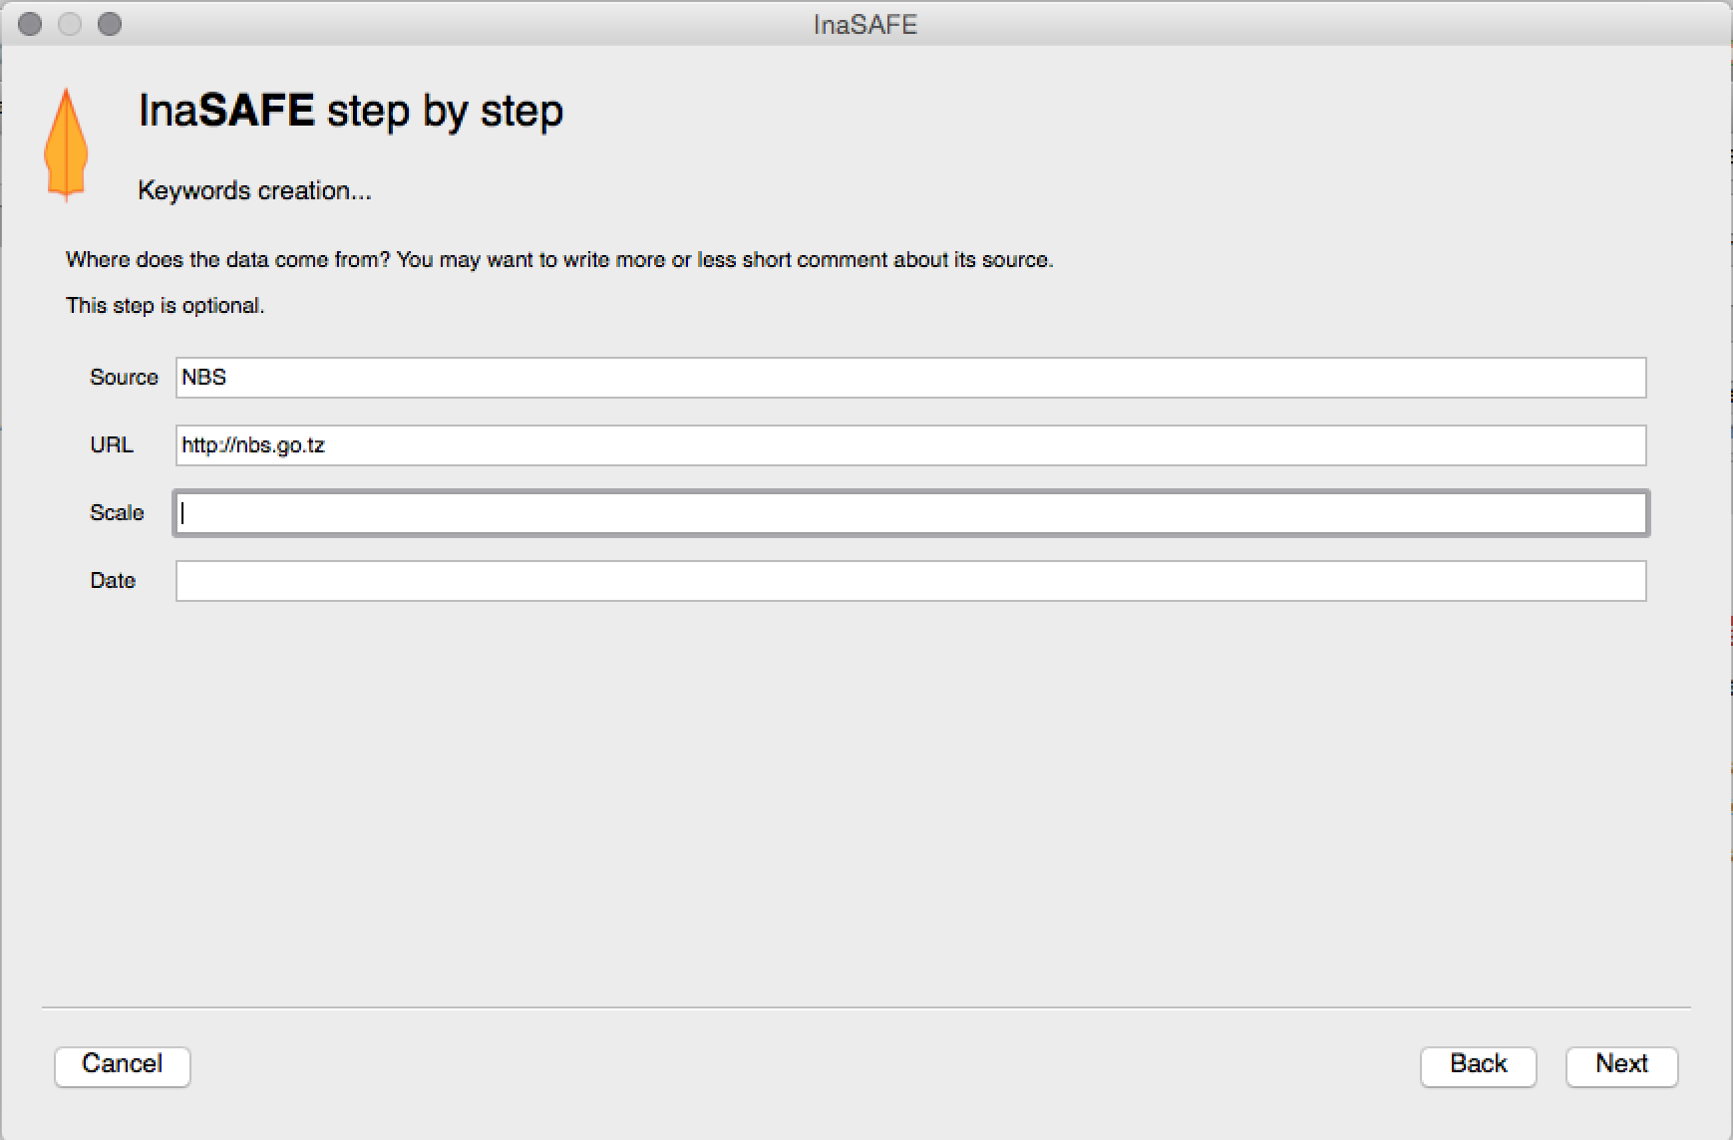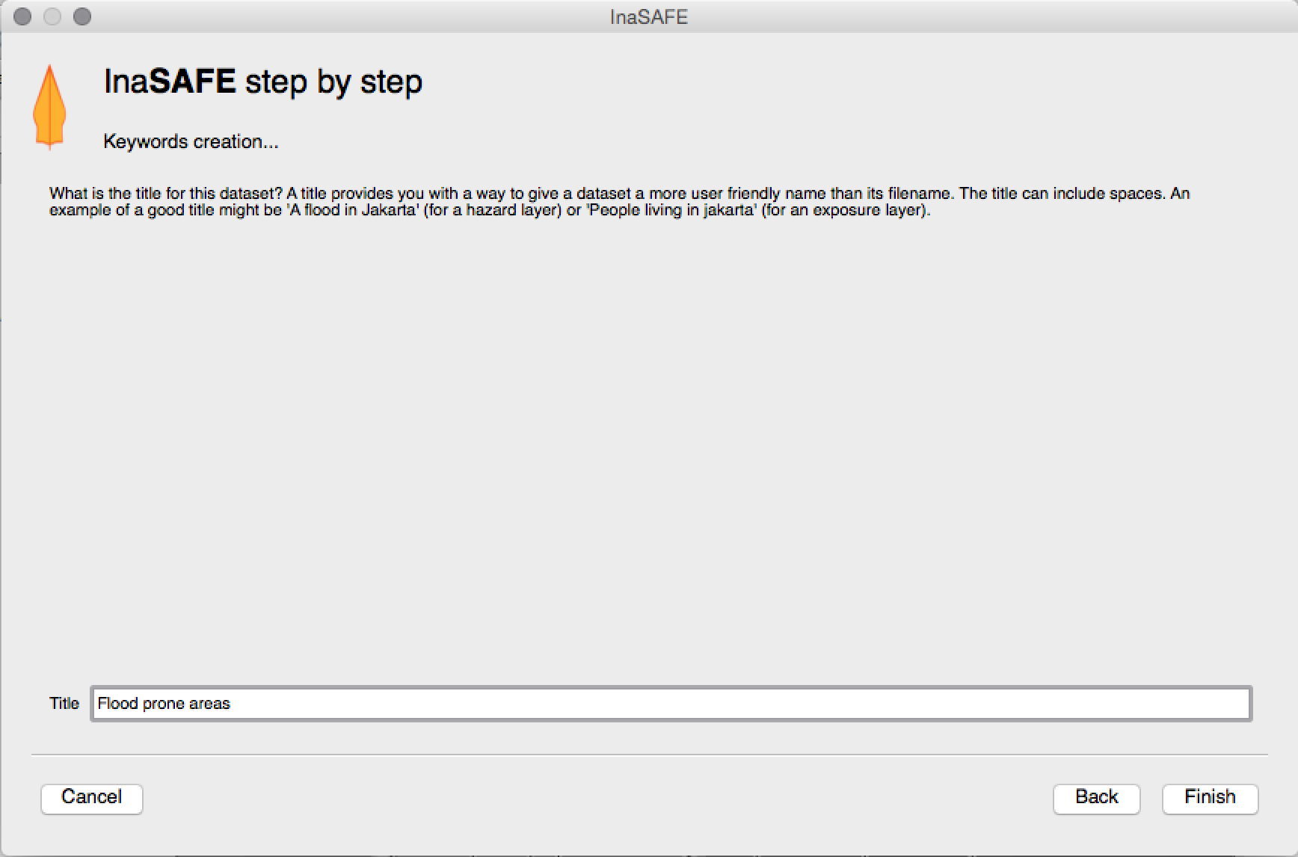

Pressing **finish** will conclude the keyword creation process. You should now see your defined keywords in the dock area of InaSAFE.

### Now you try : define the keywords for the exposure layer

Following the same process as above, define the keywords for the population exposure layer so that the keywords match those listed below.

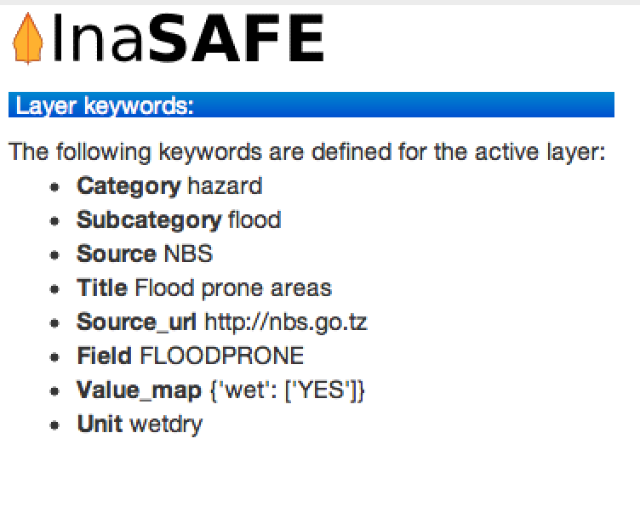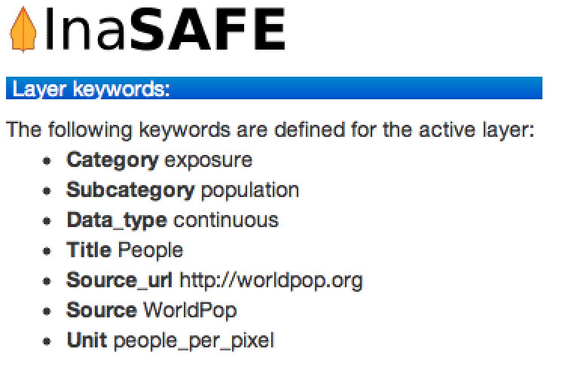

### Setting the analysis extent

We are nearly ready to run the analysis. Before we do that, we need to define what area should be used for the analysis. Click on the ‘Extent selector’ tool

## Use the dialog that appears, click ‘select on map’ and draw a box around the imagery area. Then press OK.

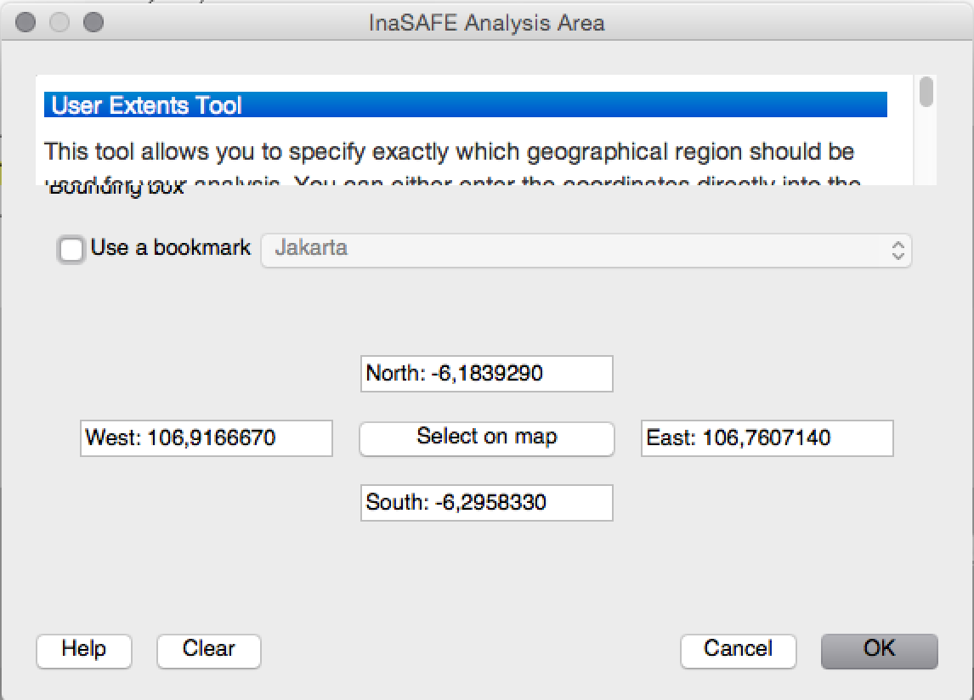

### Running the analysis

## At this stage the InaSAFE dock should show that you are ready to run a flood analysis on population. Press the Run button to commence the analysis process.

## 

## If everything was set up correctly, you should get a result in the dock area after a few seconds, and a new map layer should be added to the map.

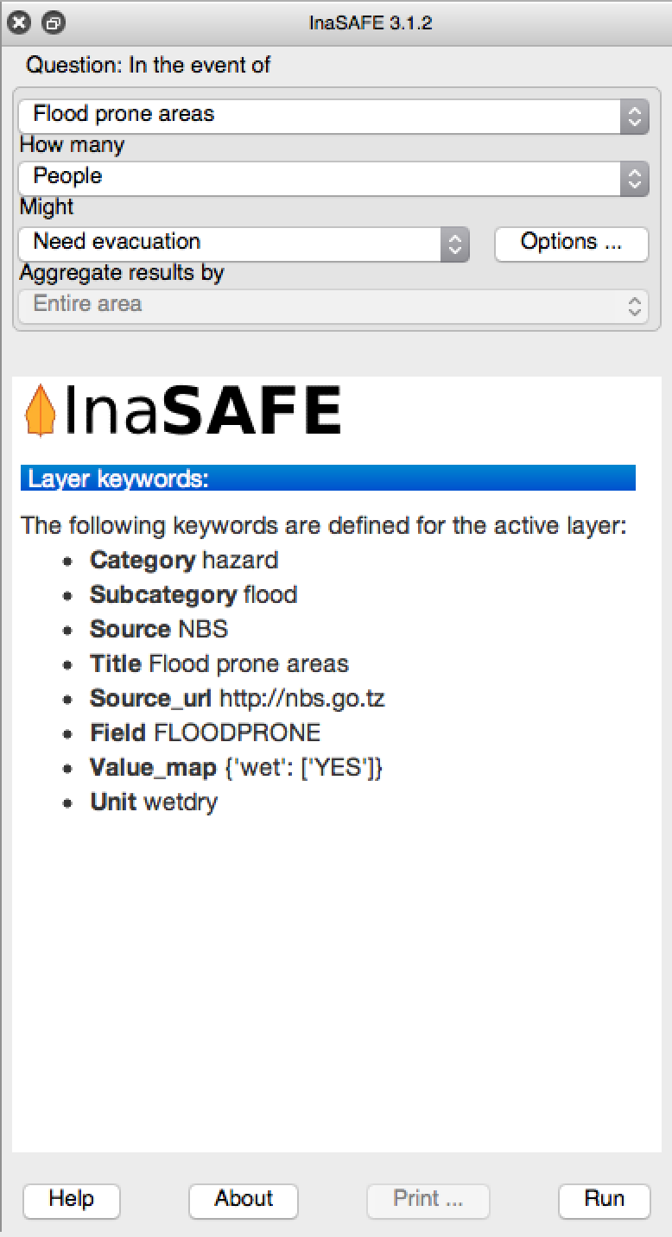

## Note: The results layer may obscure all other layers - drag it down so that you can see the Ward boundaries over it. Now press the Print button in the dock, and without changing any options press ‘Open PDF’ in the resulting print dialog.

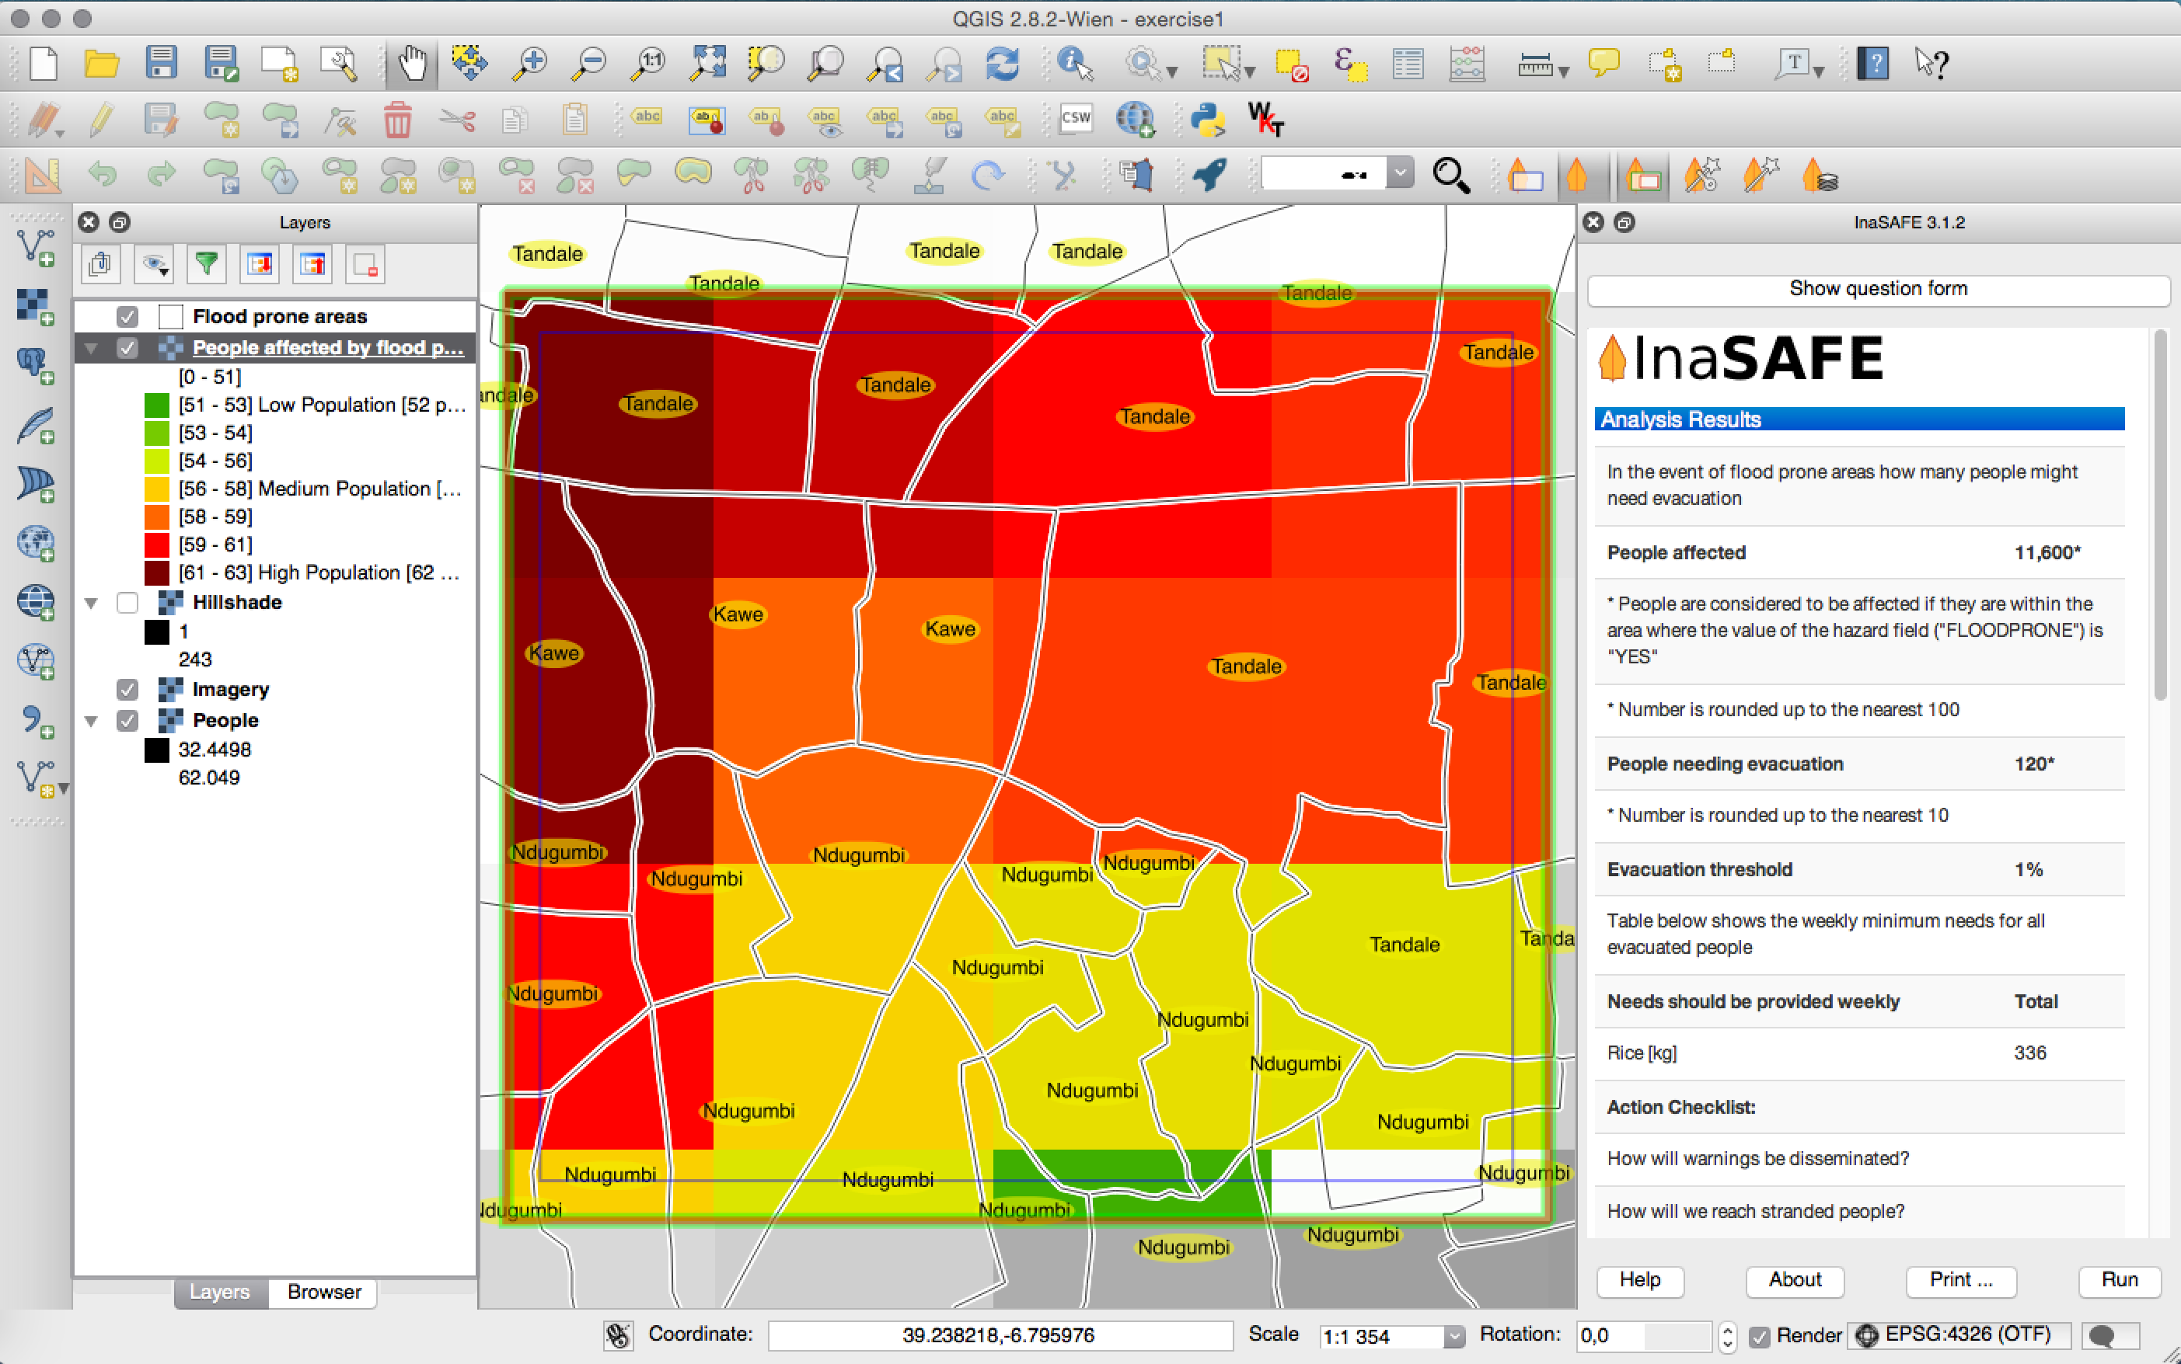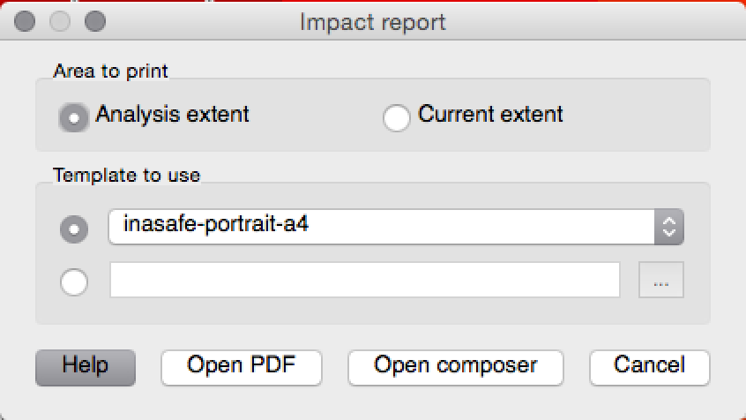

## Exercise 2 : Preparing for a flood with InaSAFE

The purpose of this workshop is to give you a small practical example of the workflows used in order to assemble the needed datasets to be used in InaSAFE. You will do some basic digitising activities, collaborate with your peer groups to exchange vital data needed to do the analysis and then perform two analyses in InaSAFE. In this session participants will be broken up into three groups:

1. Flood mappers
2. Road mappers
3. Building mappers

The exercise 2 directory contains a Sensefly Image and a QGIS project file called ‘exercise2.qgs’. The participants will be required to generate the datasets needed to prepare a contingency plan for the provided area. You will need to work together to exchange data and ensure that you can create a contingency plan.

**Important:** Before you begin digitising, set your project CRS to **EPSG: 4326**. Ask your instructor for help in doing this if needed. This is already done for you in the ‘exercise2.qgs’ project file.

### Team tasks:

**Flood mappers:** Using the provided DEM and Aerial Image as contextual backdrop layers, you will need to create a set of flooded polygons representing a fictional flood in the area covered by the provided datasets. The flood layer you generate should have the following properties:

|  |  |
| --- | --- |
| **Flood Layer** | |
| Name | tandale_floods.shp |
| Type | polygon |
| Required attribute | FLOODPRONE |
| Attribute type | text |
| Attribute length | 80 |
| Notes | Flooded areas should be non-overlapping (hit use the advanced snapping tools in QGIS to ensure polygons don’t intersect.  When capturing your flood polygons, enter either **YES** or **NO** in the **FLOODPRONE** attribute |

Tasks:

* You only need four or five polygons - take turns within your group of doing the actual digitising and entering of attributes.
* Make sure to spread your polygons across the whole sample image.
* Remember to save your edits regularly!
* Once your layer is finalised, stop editing and use the InaSAFE keywords wizard to define appropriate keywords for the layer you have created.

Bonus task:

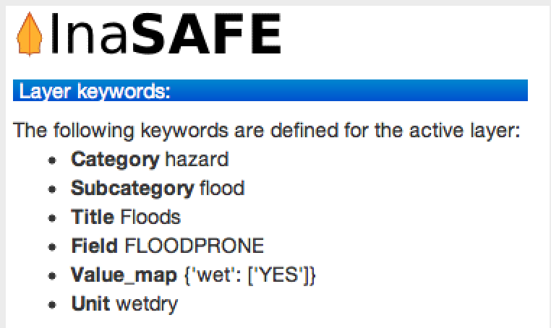

* Create a categorised renderer to style each flood polygon according to its type

**Road mappers:** Using the provided DEM and Aerial Image as contextual backdrop layers, you will need to create a set of road lines representing roads in the area covered by the provided datasets. The roads layer you generate should have the following properties:

|  |  |
| --- | --- |
| **Roads Layer** | |
| Name | tandale_roads.shp |
| Type | line |
| Required attribute | TYPE |
| Attribute type | Text |
| Attribute length | 80 |
| Notes | When capturing your road lines, use one of the following categories in the TYPE attribute:   * Motorway or highway * Motorway Link * Primary road * Primary link * Tertiary * Tertiary link * Secondary * Secondary link * Road, residential, living street, etc. * Track * Cycleway, footpath etc.   Take special care to spell these consistently |
| Required attribute | NAME |
| Attribute type | Text |
| Attribute length | 50 |

Tasks:

* Capture the roads you can see and make a quick determination as to what TYPE they should be set to.
* Take turns within your group of doing the actual digitising and entering of attributes. Remember to save your edits regularly!
* Once your layer is finalised, stop editing and use the InaSAFE keywords wizard to define appropriate keywords for the layer you have created.

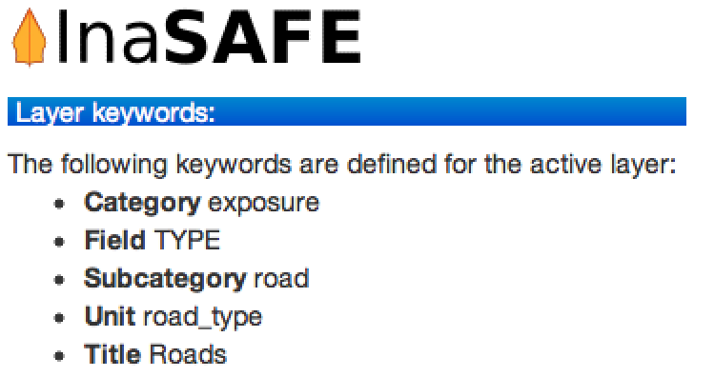

Bonus task:

* Create a categorised renderer to style each road according to its type

**Building mappers:** Using the provided DEM and Aerial Image as contextual backdrop layers, you will need to create a set of building polygons representing roads in the area covered by the provided datasets. The buildings layer you generate should have the following properties:

|  |  |
| --- | --- |
| **Buildings Layer** | |
| Name | tandale_buildings.shp |
| Type | polygon |
| Required attribute | TYPE |
| Attribute type | Text |
| Attribute length | 80 |
| Notes | When capturing your buildings, use one of the following categories in the TYPE attribute:   * Government * Place of Worship - Islam * Police Station * Residential * School * Supermarket   Take special care to spell these consistently |

Tasks:

* Capture the buildings you can see and make a quick determination as to what TYPE they should be set to.
* Take turns within your group of doing the actual digitising and entering of attributes. Remember to save your edits regularly!
* Make sure to spread your building capturing efforts across the whole of the sample image.

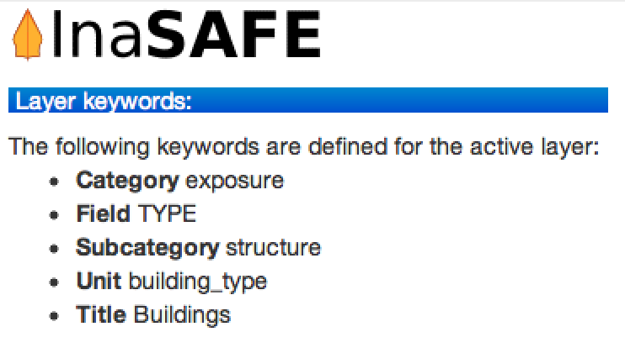

* Once your layer is finalised, stop editing and use the InaSAFE keywords wizard to define appropriate keywords for the layer you have created.

Bonus task:

* Create a categorised renderer to style each building according to its type

**All participants:**

* Once your dataset has been captured, you need to visit each of the other teams and ask them to share their data with you.
* Collate all the files (make sure to copy and share **all the files** that you created e.g. tandale_floods.shp, tandale_floods.dbf etc.) into a single directory on your computers.
* Set the InaSAFE analysis extent to the area covered by the aerial image.
* Carry out an impact assessment of the flood on roads and make a PDF of the result.
* Carry out an impact assessment of the flood on buildings make a PDF of the result.

**If you are using InaSAFE 3.1:** For roads, there is one extra thing you need to do before you can run the analysis. You need to use the **Options** button to tell the impact function some thing about your roads layer. Now set the **Affected field** to ‘**FLOODPRONE**’ and the **Affected value** to ‘**YES**’ as shown in the image below. Now press **OK** and continue with your analysis.

## Exercise 3 : Using Open Data from OpenStreetMap with InaSAFE

**Note:** For this exercise you need an internet connection, and work individually rather than in groups.

The exercise 3 directory contains a Sensefly Image, the wards layer and a QGIS project file called ‘exercise3.qgs’. The participants will be required to perform a similar exercise to the previous one, but use downloaded OSM roads and buildings for the analysis.

Start by opening the exercise3.qgs project file.



Make sure you are zoomed to the extent of the Sensefly image.

Now click on the OSM downloader icon.

A dialog will appear that looks like this:

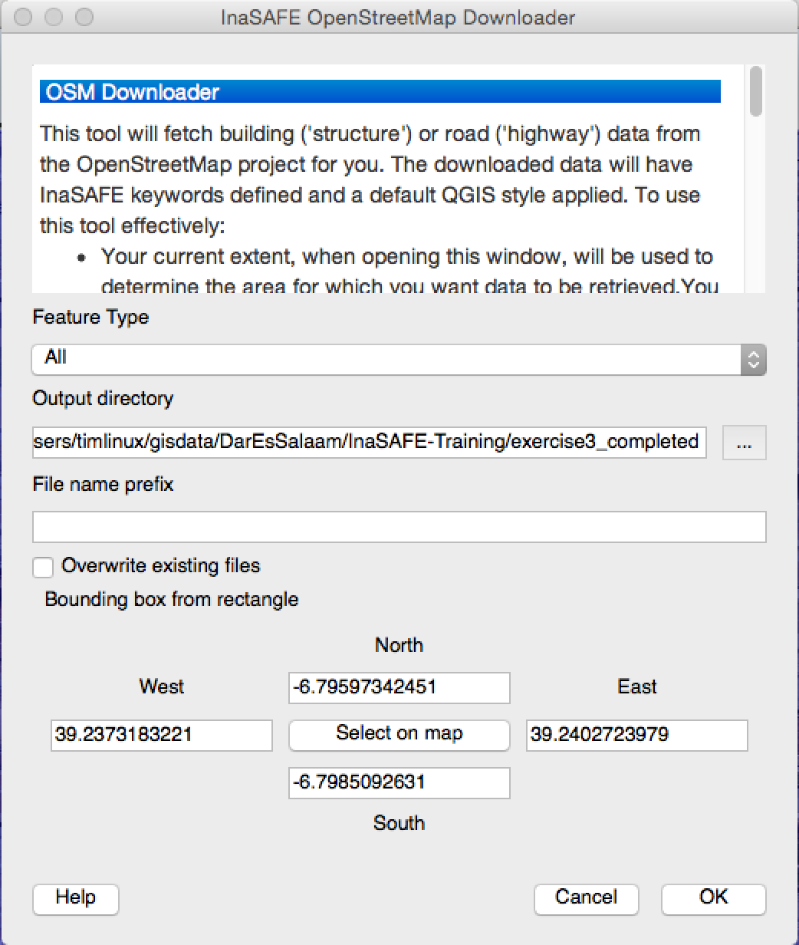

Set the ‘**Output directory**’ to your ‘exercise3’ folder.

Now press the ‘Select on map’ button and drag a box around the Sensefly image boundary.

Next press OK - again, remember that you need an internet connection for this to work.

The tool will go online and fetch road and buildings data for your study area.

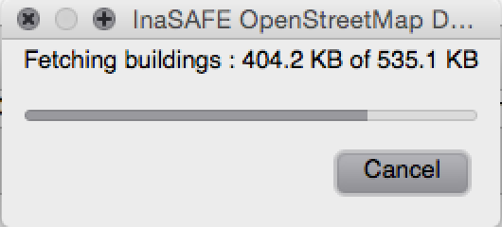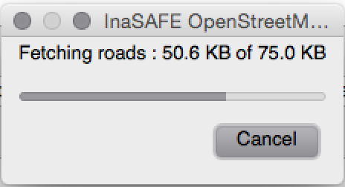

The downloader will also fetch building points. After it is done, your map may look something like this:

You will notice the dowloaded files already have their keywords set, so the data is ready to use in InaSAFE!

Your first task is to run an impact assessment on the buildings in the map.

Your second task is to run an impact assessment on the roads in the map. For roads, there is one extra thing you need to do before you can run the analysis. You need to use the **Options** button to tell the impact function some thing about your roads layer.

Now set the **Affected field** to ‘**FLOODPRONE**’ and the **Affected value** to ‘**YES**’ as shown in the image below. Now press **OK** and continue with your analysis.

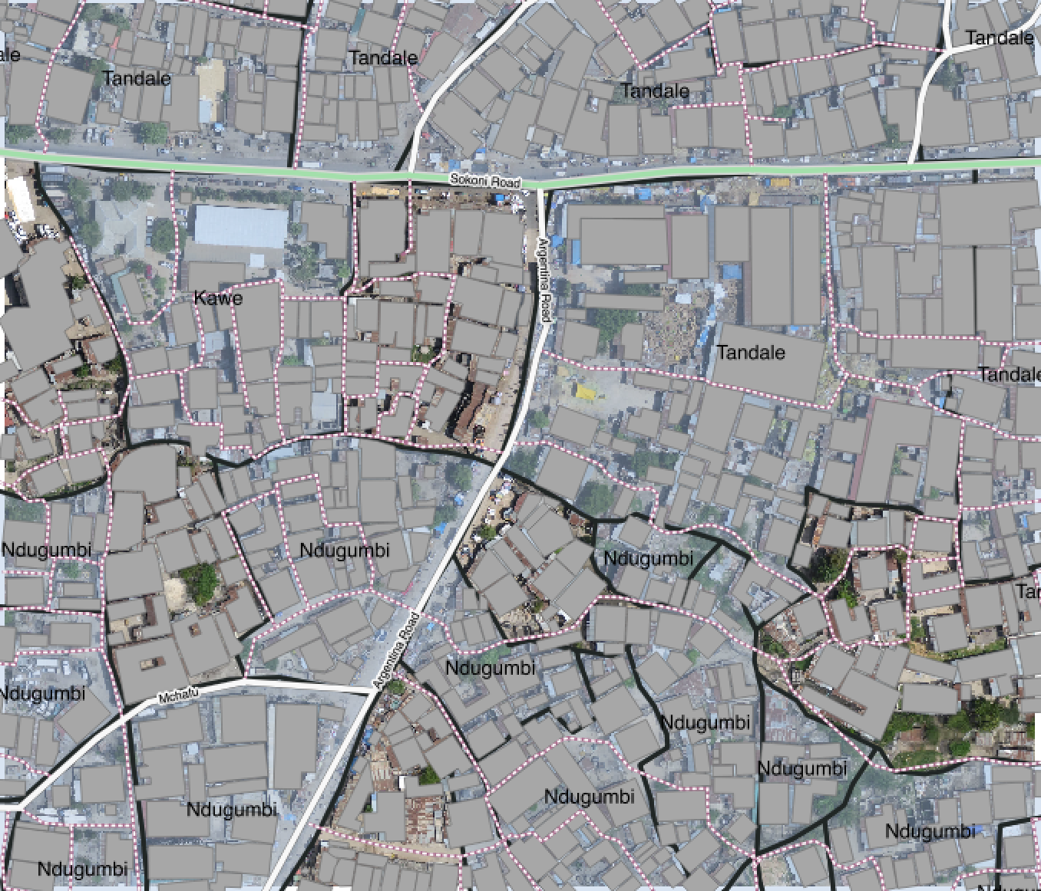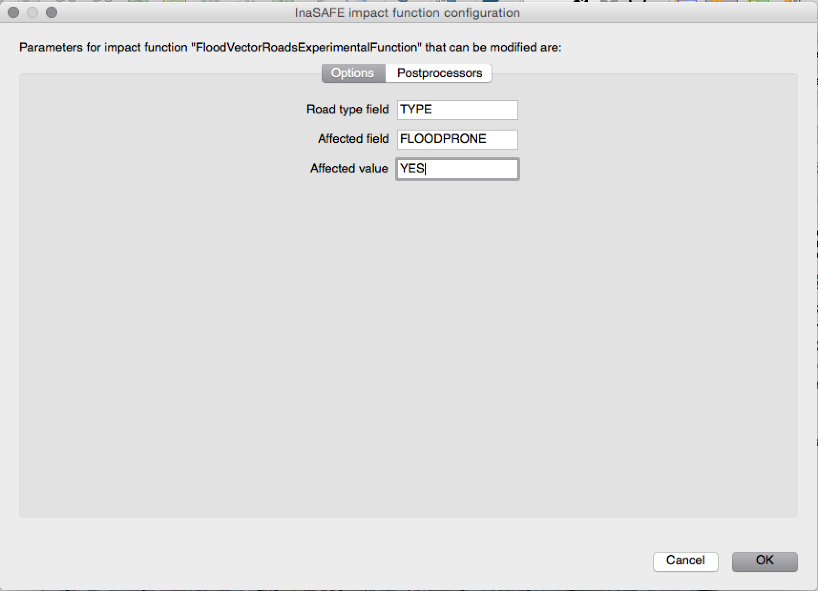

## Workshop feedback session

Participants of the workshop will be asked to provide feedback on what they produced in the workshop session, and the final analysis report will be presented.

# Day 3: Advanced InaSAFE*

*For selected group only: **Group 1:** Disaster Management Department

## Welcome

We assume that attendees already have QGIS installed (see day 1 programme) and the InaSAFE introductory session (see day 3 programme). In this day we help you to use InaSAFE in a real world context.

## Exercise 4 : Customised reports

The reports that InaSAFE produces can be customised in various ways. Most simply you can change the logo. More advanced users can build custom templates that fit your organisational needs. Lets start by using a custom Organisation Logo in your report. If you close your current project and open ‘exercise4/exercise4.qgs’ you will find the dataset that we will use for this exercise.

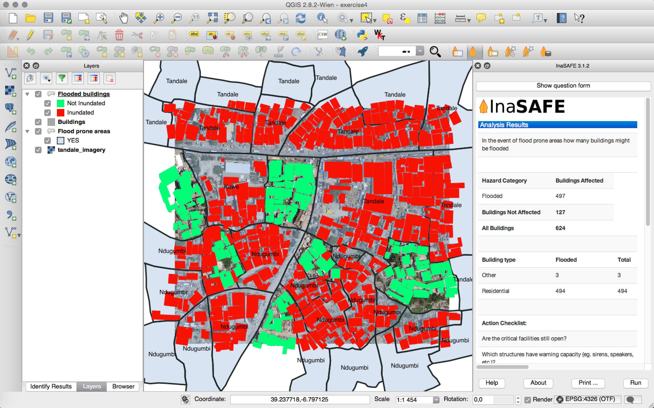

We are going to open the InaSAFE options dialog in the **Plugins -> InaSAFE -> InaSAFE Options** menu.

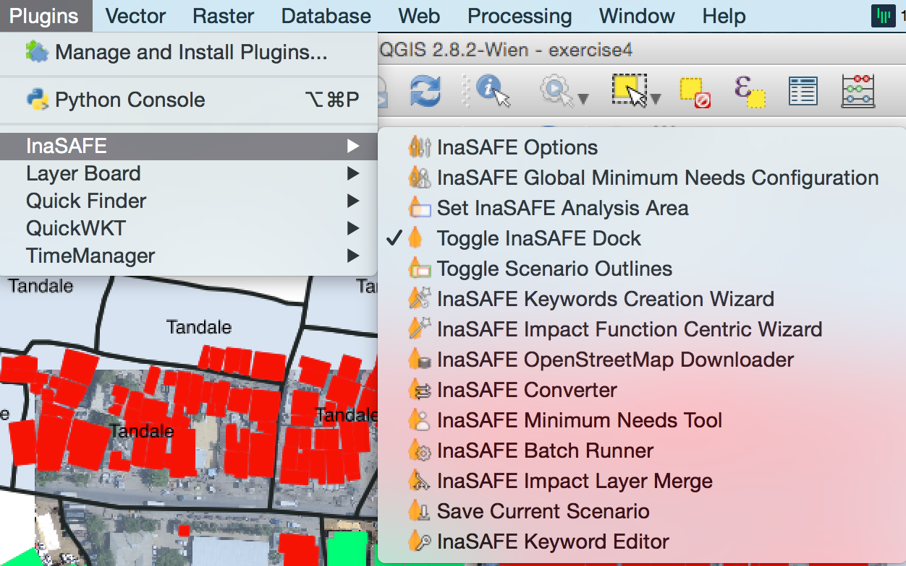

There are various things that can be customised here, but for now we will focus on the Organisation logo. Click on the second tab entitled **‘Template Options’** , check the box entitled ‘**Use custom organisation logo**’ and then press the […] button to select ‘**logo.png**’ in the exercise4 folder.

For InaSAFE you can prepare QGIS composer templates to be used in reporting. InaSAFE uses a ‘by convention’ based approach. Two conventions are supported:

* **Element ID's** - InaSAFE looks for elements with specific id's on the composer page and replaces them with InaSAFE specific content.
* **Tokens within text elements** - InaSAFE looks for text within a text item and tries to replace it. The text must be written in square brackets [ and ]

### Element-ID’s

| **Expected ID** | **Type** | **Purpose** |
| --- | --- | --- |
| **safe-logo** | Picture Item | If used, this will be replaced with the InaSAFE logo. |
| **organisation-logo** | Picture Item | If used this will be replaced with the organisation logo defined in InaSAFE options. |
| **north-arrow** | Picture Item | If used this will be replaced with a north arrow. |
| **impact-map** | Map Item | If used, this will be replaced by a legend generated by InaSAFE. |
| **impact-report** | Label Item | If used, this will be replaced with the detailed impact report. The report may be quote long so should typically be on its own page. |

Here is an example of using an element ID to place an organisation logo on the layout:

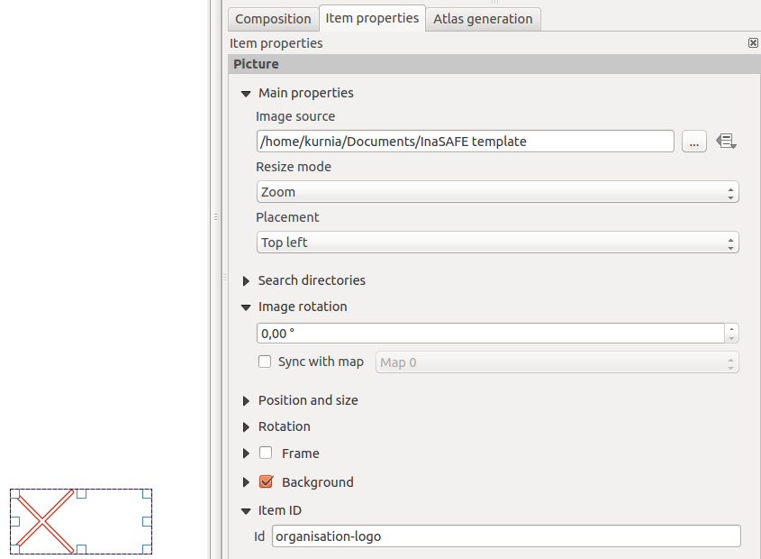

### Element Tokens

| **Expected ID** | **Type** | **Purpose** |
| --- | --- | --- |
| **[impact-title]** | Label Item | Will insert the title for the impact map. |
| **[disclaimer]** | Label Item | Will insert InaSAFE's standard disclaimer paragraph. |
| **[date]** | Label Item | InaSAFE will insert the report date in place of this token. |
| **[time]** | Label Item | InaSAFE will insert the report time in place of this token. |
| **[safe-version]** | Label Item | InaSAFE will insert the version of InaSAFE used to generate the report. |

Here is an example of using replacement tokens in a text item. The **[date]**, **[time]** and **[safe-version]** will be replaced with the appropriate content when the template is rendered.

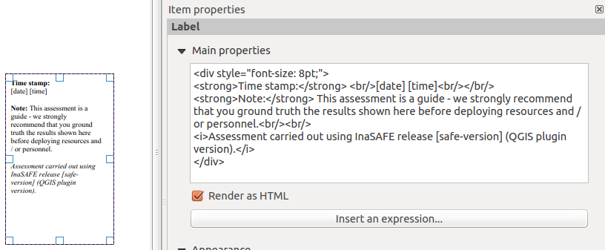

Now you try. Using the above tables, create your own template (refer to your QGIS training course notes if needed on how to create the composer template), using the the element identifiers and element tokens as outlined above to create your own customised map template.

Once you have created your composer template, save it in your project directory as ‘**custom-template.qpt**’ and then follow this procedure to generate an InaSAFE map using the template:

* Select the ‘**Flooded buildings**’ impact layer in the Layers panel
* Press the ‘**Print**’ button in the InaSAFE dock window
* In the dialog that appears, check the **second radio button**
* Now choose the ‘**custom-template.qpt**’ file you made above
* Press the **‘Open PDF’** button to create the map, and choose an output directory (or just press OK) to have it generated.

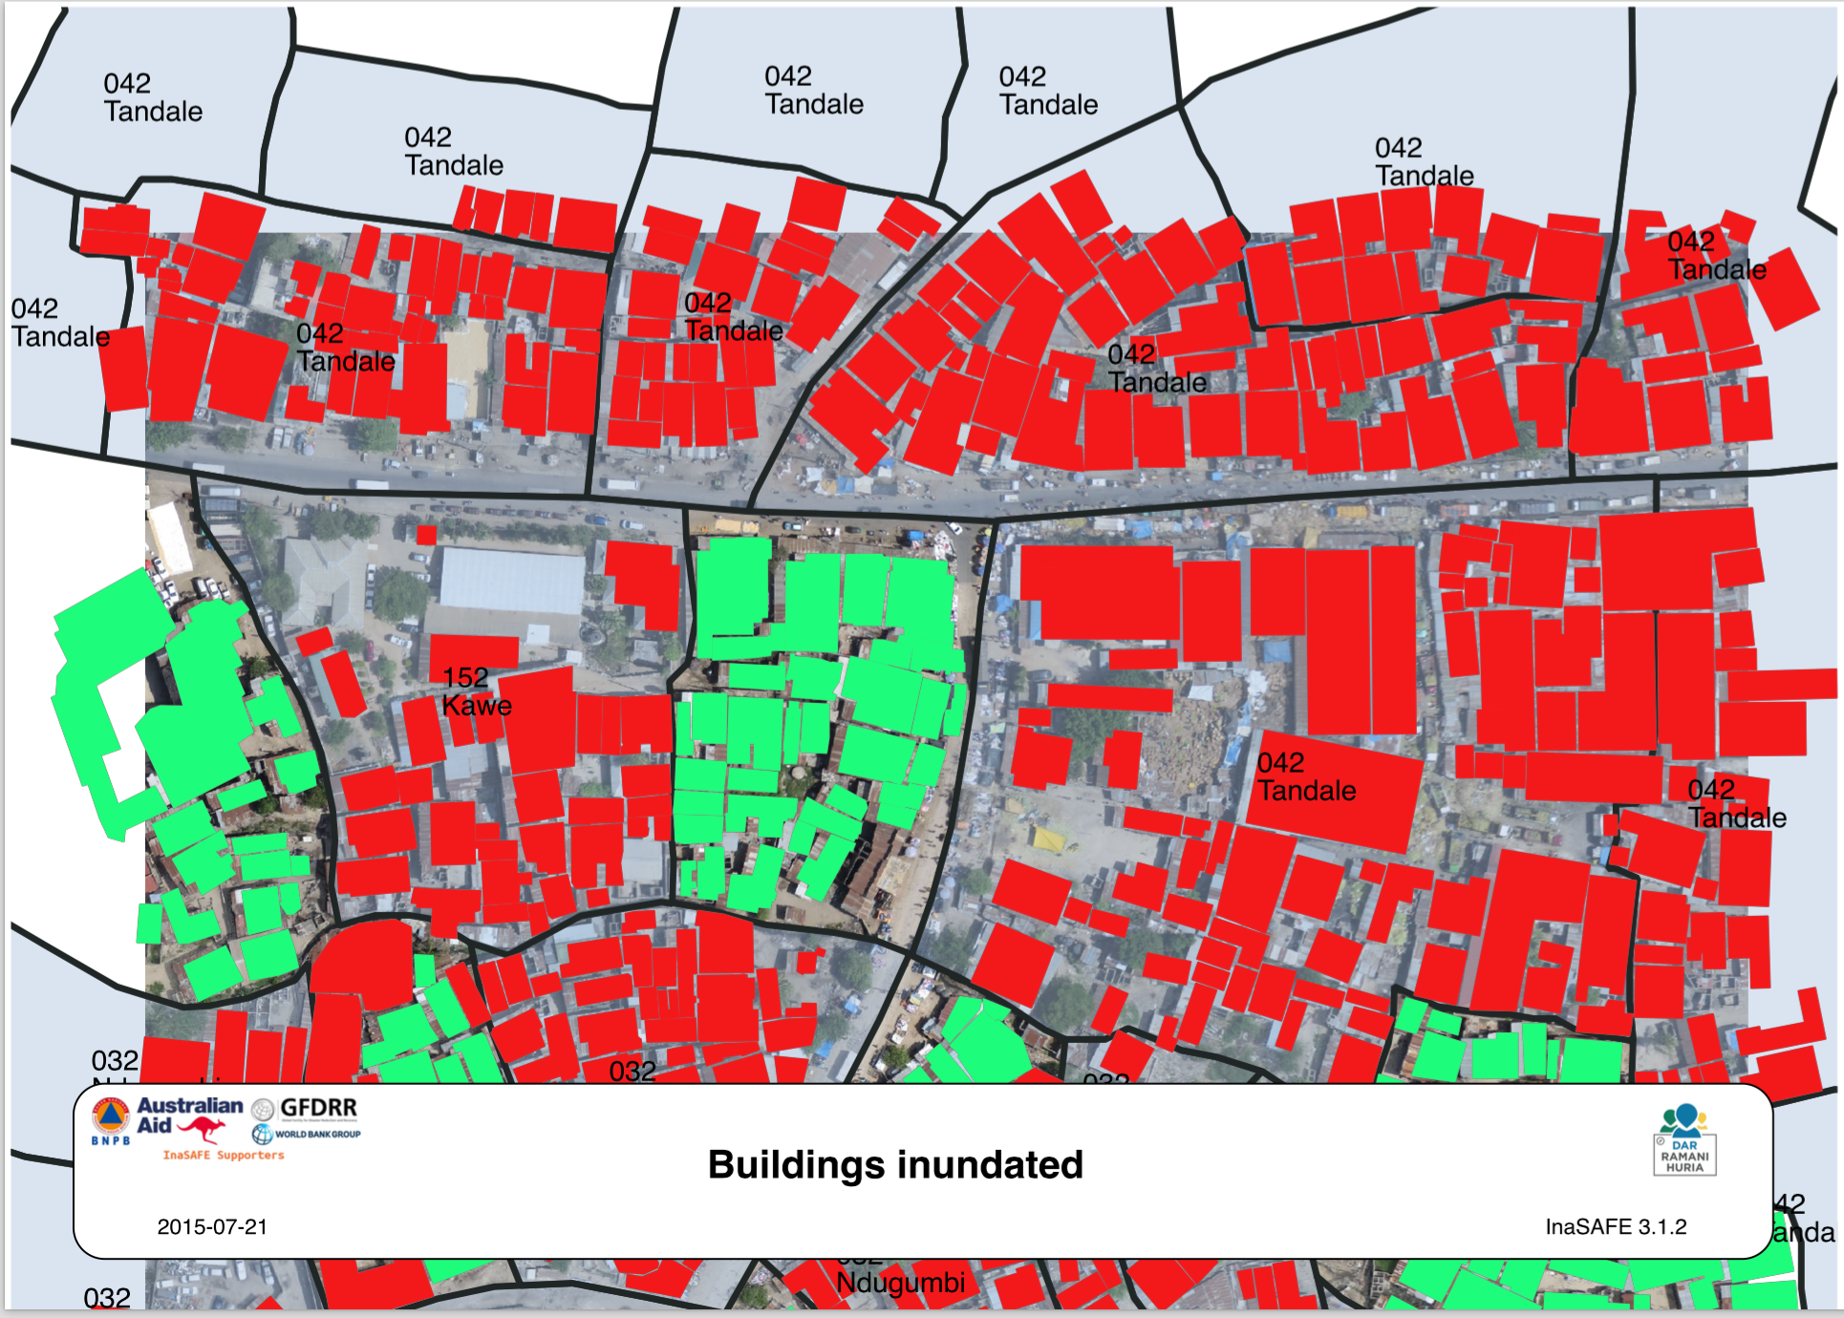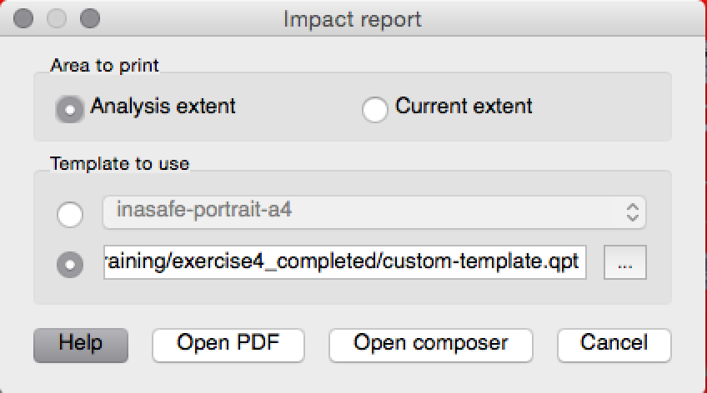

Here is what my template looked like - be creative and see what you can make!

## Exercise 5 : Minimum needs

During and after a disaster, providing for the basic human minimum needs of food, water, hygiene and shelter is an important element of your contingency plan. InaSAFE has a customisable minimum needs system that allows you to define country or region specific requirements for compiling a needs report where the exposure layer represents population.

By default InaSAFE uses minimum needs defined for Indonesia - lets look at how to create a new profile and apply it to a flood on population analysis.

Close your current project and open ‘exercise5/exercise5.qgs’ you will find the dataset that we will use for this exercise. Start by opening the Global Minimum Needs Configuration as shown in the image below (**Plugins -> InaSAFE -> InaSAFE Global Minimum Needs Configuration**).

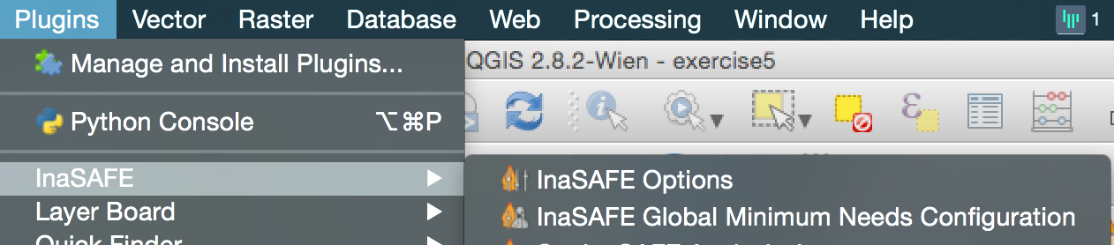

Minimum needs are grouped into regional or linguistic ‘profiles’. The default profile is ‘BNPB_en’ - the english profile for the national disaster agency in Indonesia.

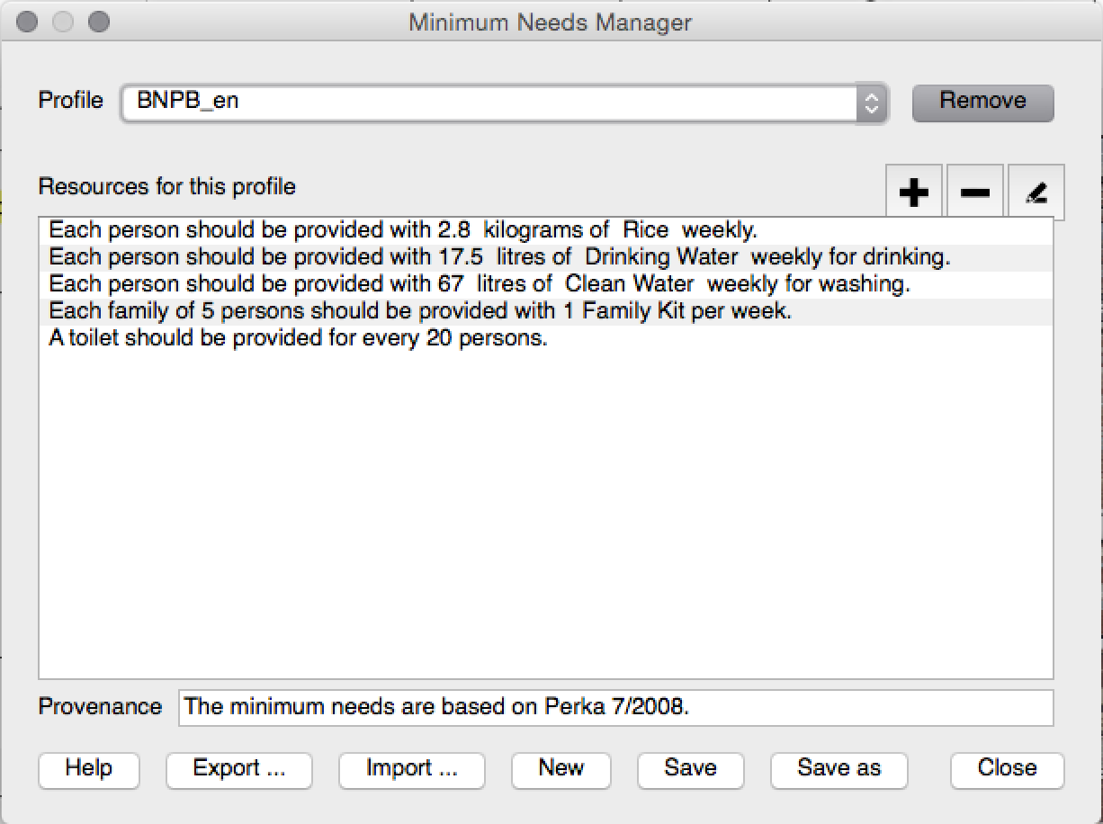

You will see that their profile defines requirements for displaced persons in terms of Rice, Drinking Water, Clean Water (for bathing etc.), Family Kits (with personal hygiene items) and provision of toilets.

Each item in the profile can be customised or removed. For example selecting the first item in the list and then clicking on the ‘**pencil**’ icon will show the details of how it was defined.

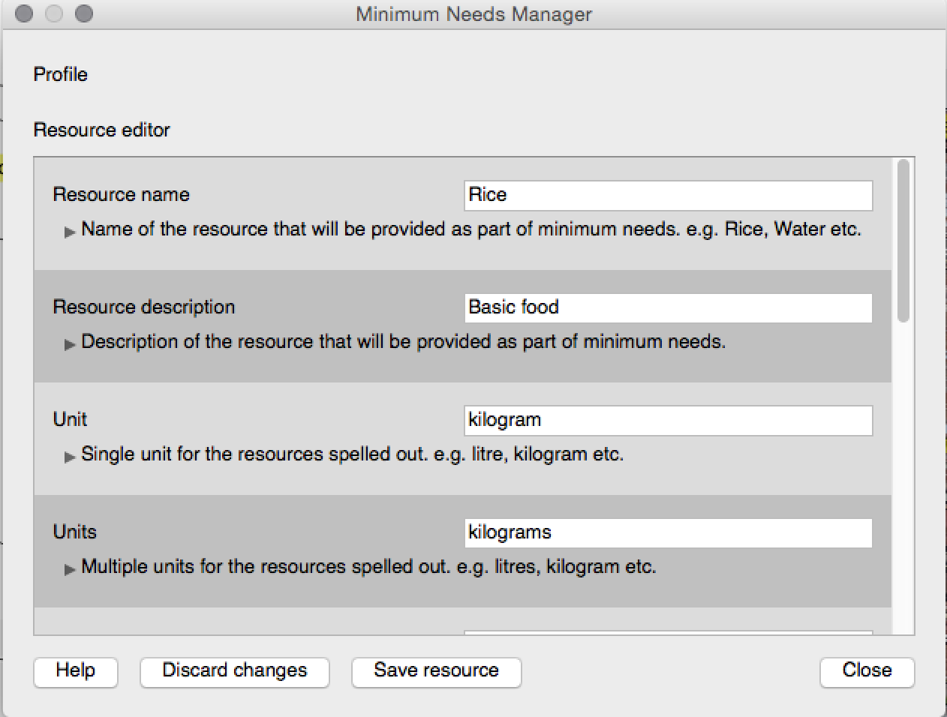

If you scroll up and down in the panel you will see that for each item, you can set a name, description, units (in singular, plural and abbreviated forms), specify maxima and minima for the quantity of item allowed, a default and a frequency. You would use the maxima and minima to ensure that disaster managers never allocate amounts that will not be sufficient for human livelihood, and also that will not overtax the logistics operation for those providing humanitarian relief.

The final item in the item configuration is the ‘readable sentence’ which bears special discussion. Using a simple system of tokens you can construct a sentence that will be used in the generated needs report.

Press the **close** button on the dialog so that you return to the main profile list. Now let’s create our own profile! Press the **new** button to create a new profile. A dialog will appear asking for the name of your profile. Call it ‘training’ and press ‘**save**’.

The first thing to do is to enter the ‘provenance’ for the profile. Typically you should enter a short statement explaining which legislation or guideline was used to define this needs profile. In our case we will just use a sentence like ‘Needs as defined for InaSAFE Training Course’ to make it clear that this is just a training profile.

Now click the **add** button and create a new need item with the following properties.

| **Property** | **Value** |
| --- | --- |
| **name** | Rice |
| **description** | Rice for daily meals |
| **units** | Kilogram |
| **unit** | Kilograms |
| **unit abbreviation** | kg |
| **maximum** | 1 |
| **minimum** | 5 |
| **default** | 2.5 |
| **frequency** | weekly |
| **readable sentence** | Requirements for {{ Resource name }} : {{ Default }}{{ Units }} {{ Frequency }}. |

Now press the **save resource** button

You will be taken back to the profile screen, press **save** again.

Now close and restart QGIS, then open the needs manager dialog again and ensure that your new profile is selected, the close the dialog.

Now run the **flood on population** analysis again and view the impact summary:

**Now you try:** Try to edit the minimum needs profile by adding your own needed item, save and close QGIS, open it again and then run the analysis again. Can you see your new item added?

## Aggregation

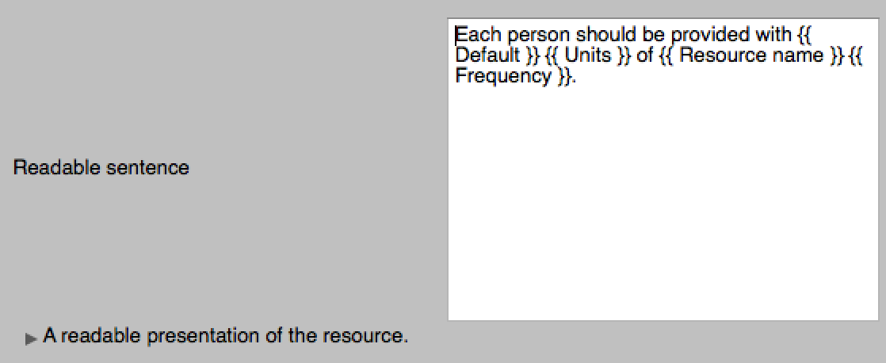

In this session we will do a walk through the aggregation system in InaSAFE and explain how to prepare an aggregation dataset. As we mentioned in our overview at the start of this document, aggregation is the process whereby we group the results of the analysis by district so that you can see how many people, roads or buildings were affected in each area. This will help you to understand where the most critical needs are, and to generate reports as shown in the image below.

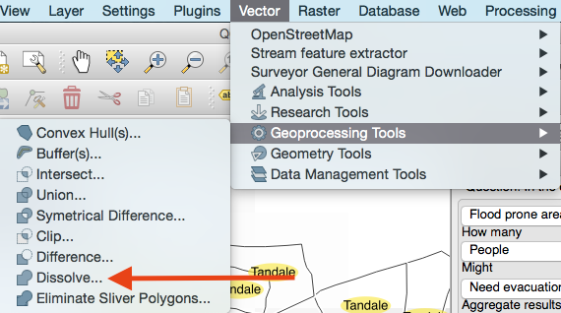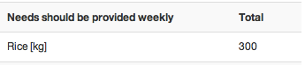

To do aggregation we need to have a layer with keywords for aggregation defined.

Select flood prone areas layer

Then use **Vector -> Geoprocessing Tools -> Dissolve** with these options:

* Input vector layer: **Flood prone areas**
* Leave ‘Use only selected features’ **unchecked**
* Dissolve field: **Ward_Name**
* Add result to canvas: **checked**

## Click ok to create the new layer. Now create keywords for your new layer as per the list below:

* **Category** postprocessing
* **Aggregation attribute** Ward_Name
* **Title** Wards
* **Url** http://nbs.go.tz
* **Elderly ratio** attribute Global default
* **Youth ratio default** 0.26
* Source National Beaureau of Statistics, Tanzania
* **Elderly ratio default** 0.08
* **Adult ratio attribute** Global default
* **Female ratio attribute** Global default
* **Youth ratio attribute** Global default
* **Female ratio default** 0.5
* **Adult ratio default** 0.66

Now you can run the analysis using the aggregation areas set to ‘Wards’ as shown below.

## When the analysis completes, the report will be broken down by ward.

Press run and the report shows results by ward.

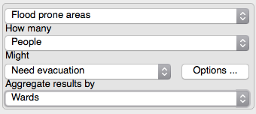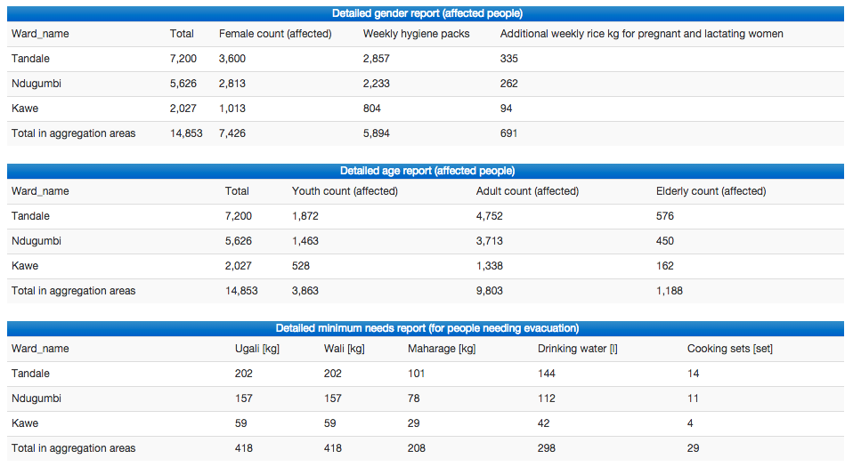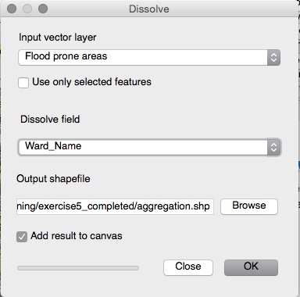

## Dealing with errors and troubleshooting

In this session we will show the participants different kinds of issues they may encounter when using InaSAFE and how to get help when encountering such issues.

We try our very best to make InaSAFE a top quality project, with many tests and checks in place to ensure that quality of the software does not slip. However as with all software packages, sometimes things go wrong, and we would like to know about it. The best way to report a problem is to use our GitHub issue tracker. To use the issue tracker you first need to register an account on GitHub - it is free and quick and easy to do:

* Go to <https://github.com/join>
* Fill out the details in the form to create your account, then log in

To tell us about a problem you have encountered, you can now go to: <http://github.com/AIFDR/inasafe/issues> . The first thing you should try to do is scan the list of issues / search through them to see if someone has already reported it. If not use the add issue button to create a new issue. When writing your issue, here are some helpful hints that will ensure that the developers are able to respond to and fix your issue easily.

* If possible provide a link to the datasets you were using so that the developer can recreate the problem using the same data you had.
* Describe step by step the process you followed when you encountered the ticket
* Make the subject line short and clear e.g. ‘Crash when editing minimum needs’ or ‘Map shows incorrect scale when making PDF’.
* Make sure you provide a way for the developer to get into contact with you - at least check the email account that you signed up to GitHub with regularly so that you can see when the developer is looking for new information.
* Try to make your expectations realistic - are you asking the developer to do something that requires a complete re-write of the software? Perhaps you can rather find a suggestion that will solve your problem with as minimum effort as possible on the part of the developers.
* Provide a screenshot or image of the problem if possible. Its very easy to add images to your issue - just drag and drop them into the issue description area on the new GitHub ticket.
* If you see an error message or dialog box appear with what looks like programme code, copy and paste the content into your ticket or make a screenshot of it (we prefer if you can paste the actual text).

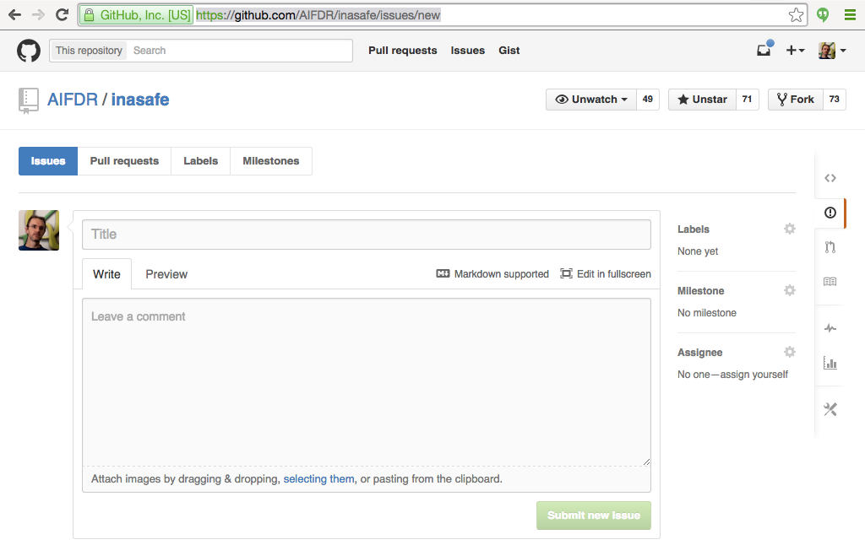

## Preparing for a flood with InaSAFE

In this session we will repeat the exercise from the introductory course, but attendees will be given all the data they need, and then be expected to complete the entire workflow of preparing their contingency plan **on their own**.

## Workshop feedback session

Participants of the workshop will be asked to provide feedback on what they produced in the workshop session, and the final analysis report will be presented.